Project Report

Qualification Name | PDDS Professional Diploma in Data Science (E-Learning)
Module Name | WSQ -Deep Learning (SF)

Student name |  | Assessor name
MAS IMRAN |  | MR RAJEEV
Date issued | Completion date |  | Submitted on
5/2/2025 | 12.2.2025 |  | 12.2.2025
Project title | Image Analysis, Classification, Video Analysis, and Text Analysis Using Azure AI Services

Learner declaration
I certify that the work submitted for this assignment is my own and research sources are fully acknowledged.

MAS IMRAN
Student signature: Date: 5/2/2025

Content
- Project Overview 2
- Project Technical Environment 3
- Milestone 1 4
- Milestone 2 5
- Milestone 3 6
- Milestone 4 7
- Conclusions and Future Scopes 8

Project Overview (Explain the Project in your own words in 15 – 20 lines)
This project focuses on utilizing Azure AI services for image analysis, classification, video analysis, and text analysis within an automotive industry context. The fictitious company, ABC Automobile Support Co., aims to enhance business operations, safety, and customer satisfaction through AI-driven insights. The project comprises four key components:
Image Analysis for Road Safety: Using Azure AI Vision to monitor traffic patterns, detect vehicles at intersections, and optimize road design.
Image Classification for Vehicle Identification: Implementing Azure Custom Vision to classify vehicles into predefined categories such as cars, motorcycles, and planes.
Text Analysis of Customer Reviews: Leveraging Azure Language Services to analyze customer feedback and extract sentiments, key phrases, and named entities.
Video Analysis of Automotive Industry Trends: Utilizing Azure Video Indexer to extract insights from industry-related videos for strategic decision-making.
The project follows a structured approach, ensuring practical implementation and assessment through a summative evaluation. Each milestone aligns with AI service capabilities and contributes to the company's data-driven decision-making.
Project Technical Environment
Technical Tools Used:
Azure AI Vision for image analysis and object detection
Azure Custom Vision for image classification
Azure Video Indexer for extracting insights from videos
Azure Language Services for sentiment analysis and key phrase extraction
AI-102 Lab Environment for implementing and testing the AI solutions
Approach to Execution:
Setting up Azure AI resources and configuring the necessary services.
Uploading and processing datasets specific to each milestone.
Implementing AI models for image classification, sentiment analysis, and video insights extraction.
Evaluating and documenting results for each milestone.
Azure AI Services Overview:
Azure AI Vision: Enables image and video analysis for object detection and scene understanding.
Azure Custom Vision: Allows training of machine learning models for custom image classification.
Azure Language Services: Provides natural language processing capabilities, including sentiment analysis and named entity recognition.
Azure Video Indexer: Extracts metadata, transcripts, and insights from video content.

- Milestone 1
Tasks and Activities:
Create Azure AI Service Resource: Setting up the AI resource in Azure.
Upload Road Safety Dataset: Images containing traffic intersections and vehicles.
Apply Image Analysis Features: Using Azure AI Vision for vehicle detection and traffic pattern monitoring.
Evaluate and Document Results: Analyzing extracted insights and visual outputs.
Outcome:
Identification of vehicles in high-traffic areas.
Insights into congestion points for potential road design improvements.
Screenshots: (Include screenshots of Azure AI Vision setup, image processing steps, and analysis results.)
- Azure AI Service Resource Setup: Screenshot of the Azure AI service resource created in the Azure portal.
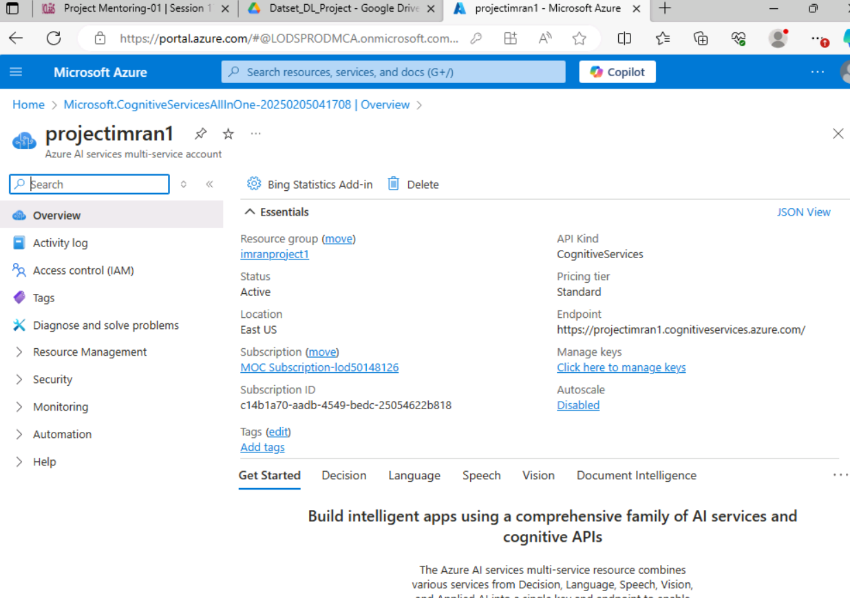

- Image Upload to Azure AI Vision: Screenshot showing the road safety dataset images uploaded in the Azure AI Vision.
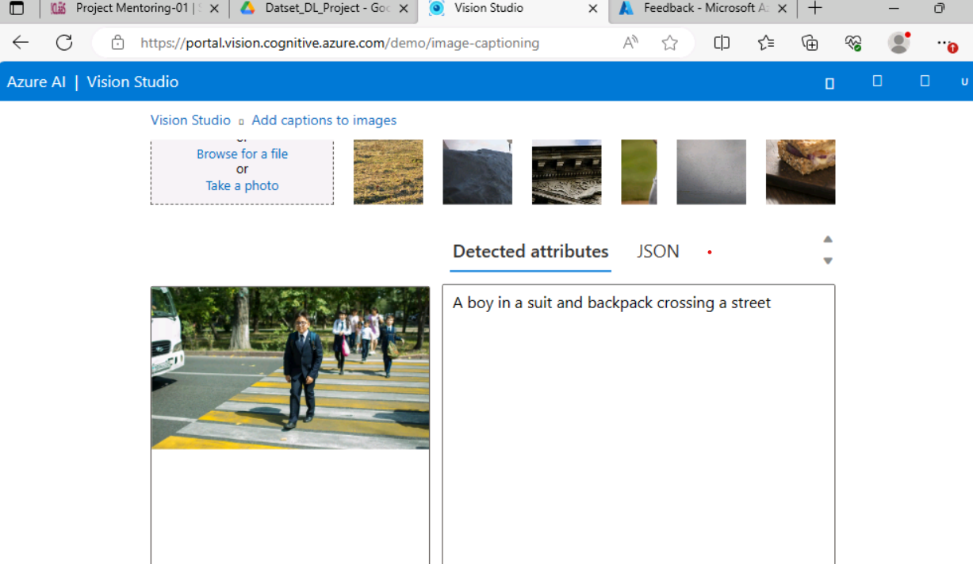
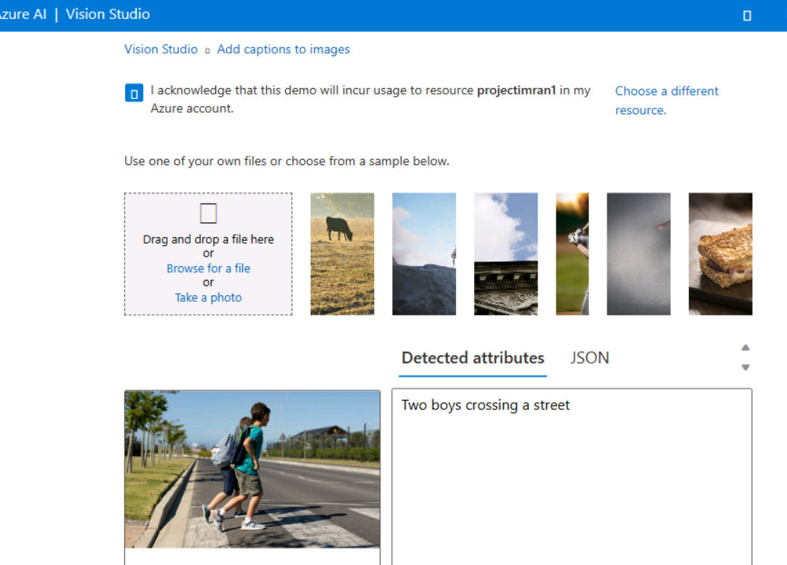
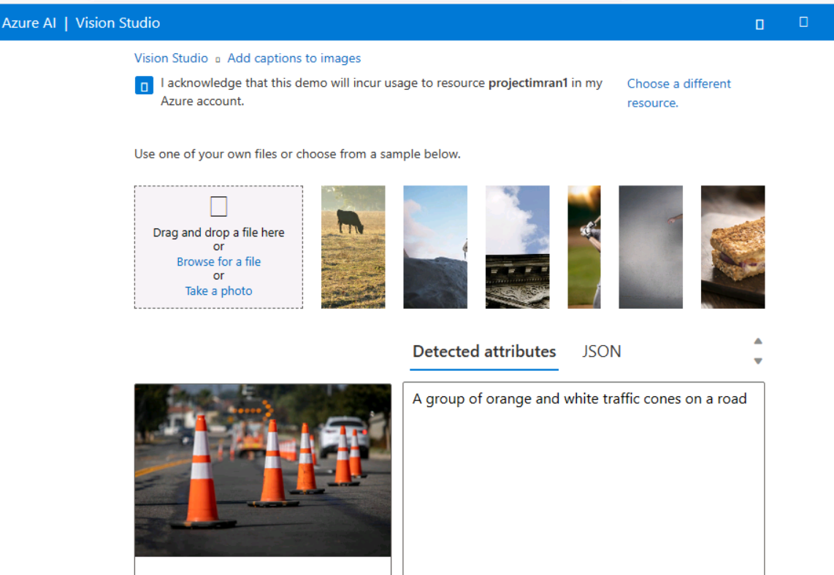
- Image Analysis Setup: Screenshot of the image analysis process being configured in the Azure AI Vision portal.
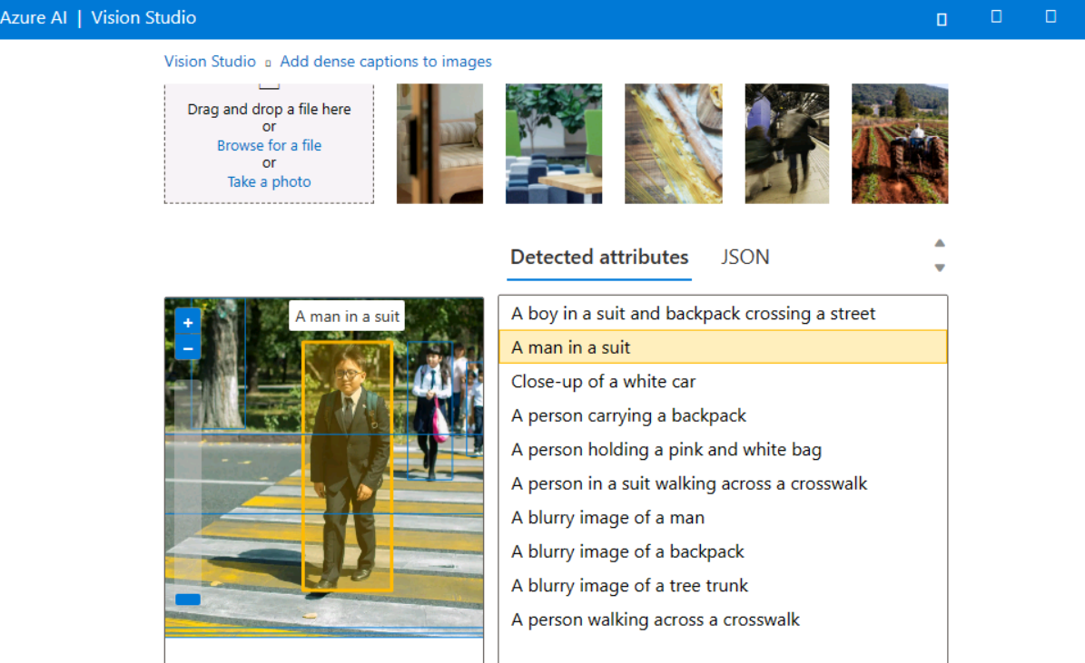
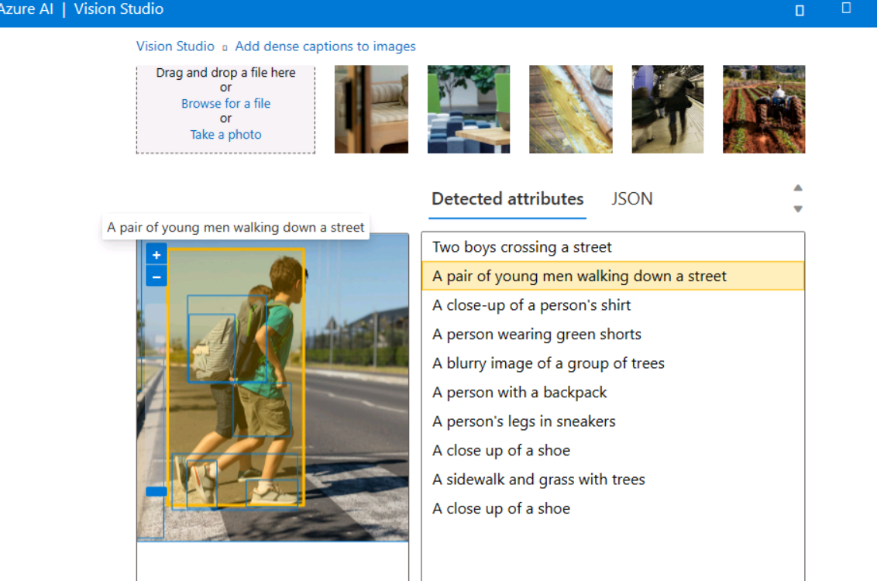
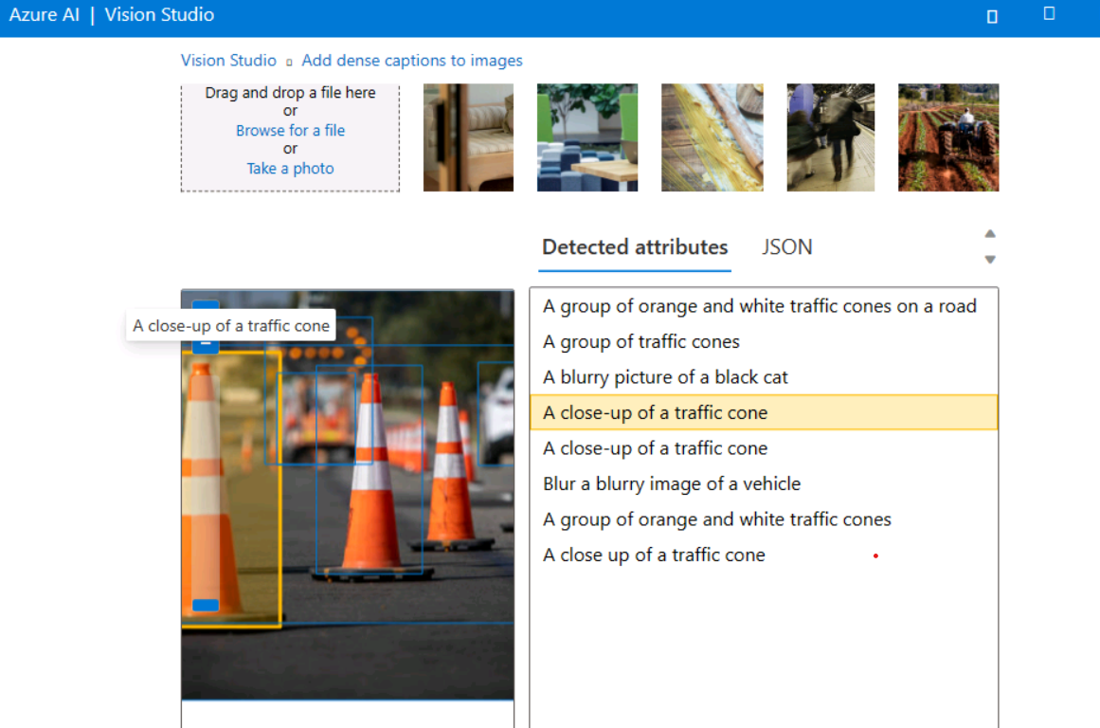

- Image Analysis Results: Screenshot showing image analysis results.
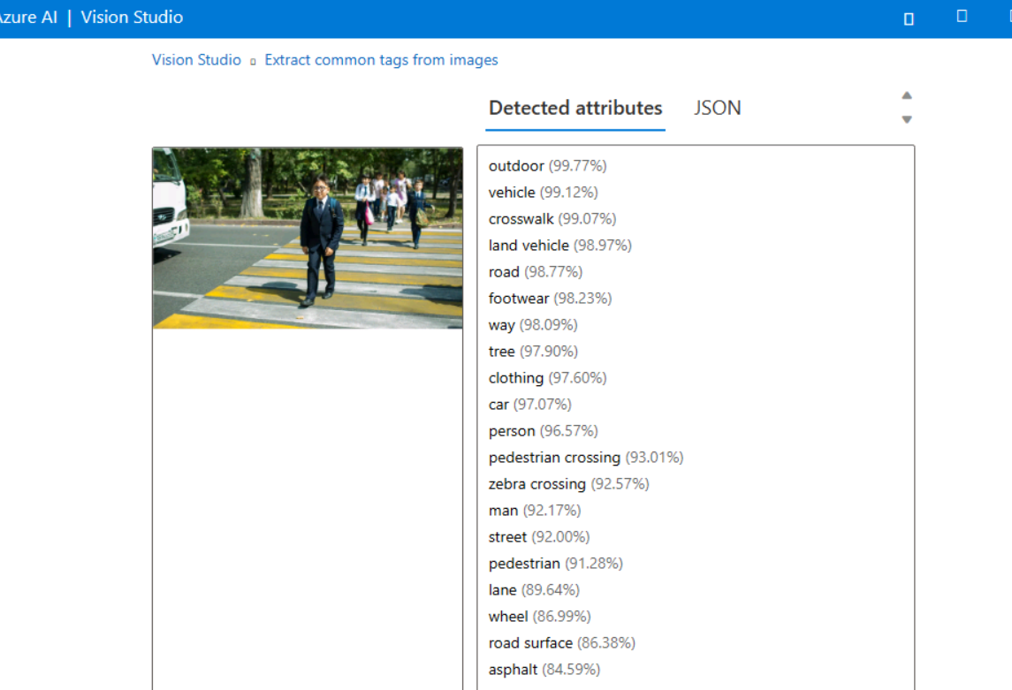
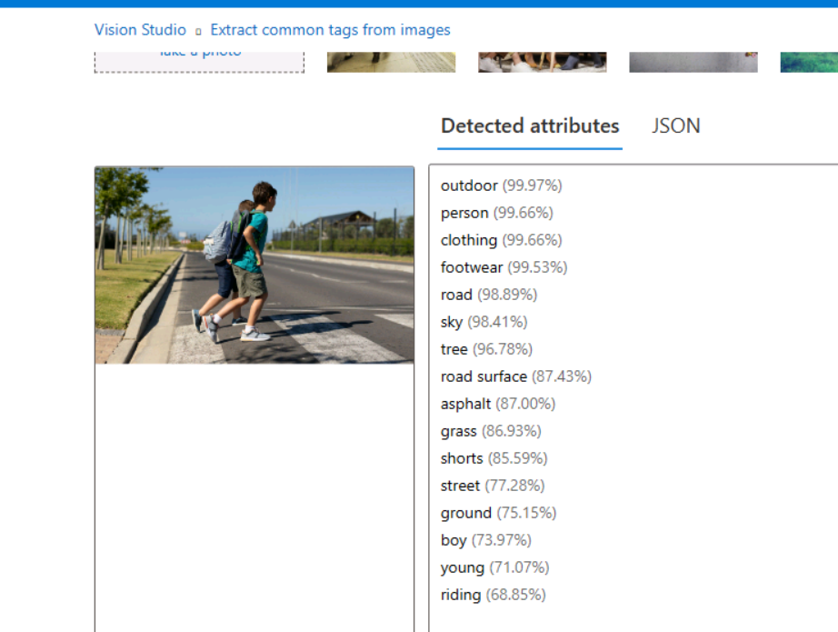
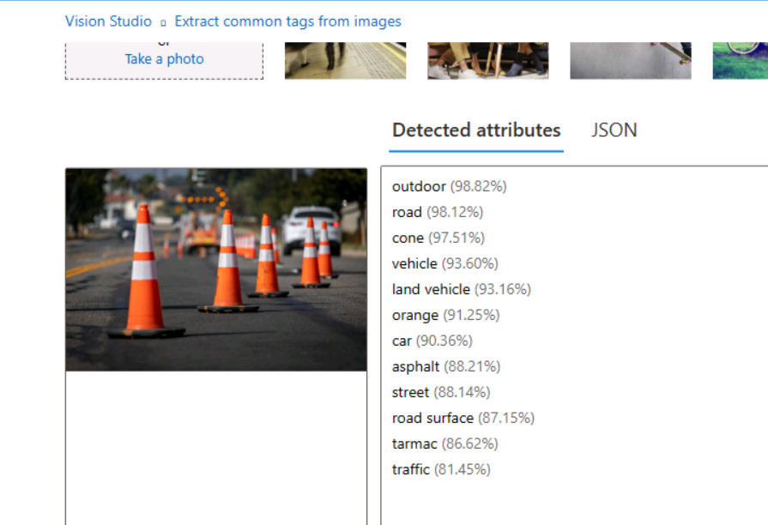
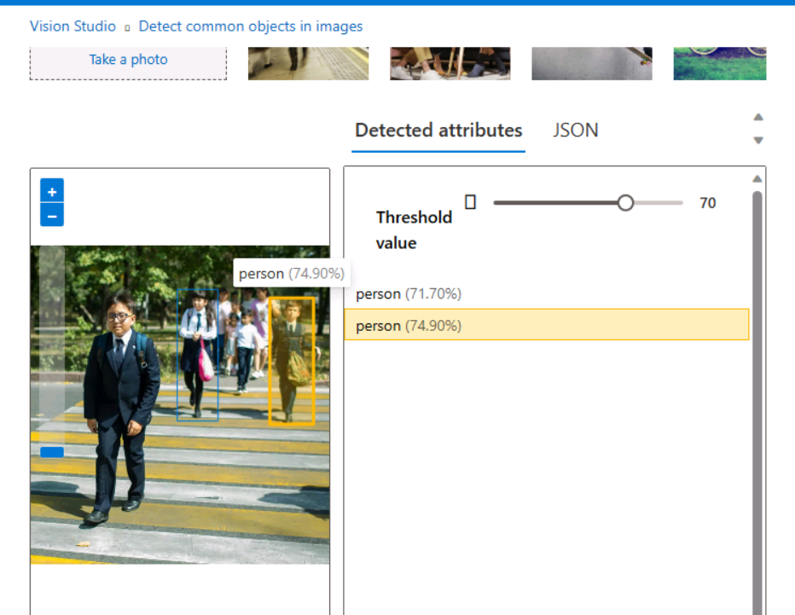
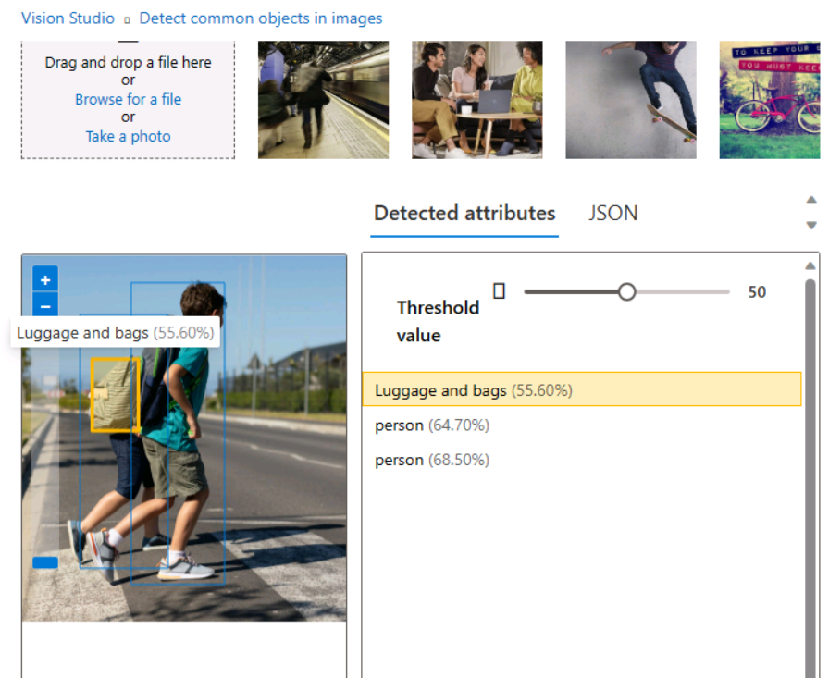
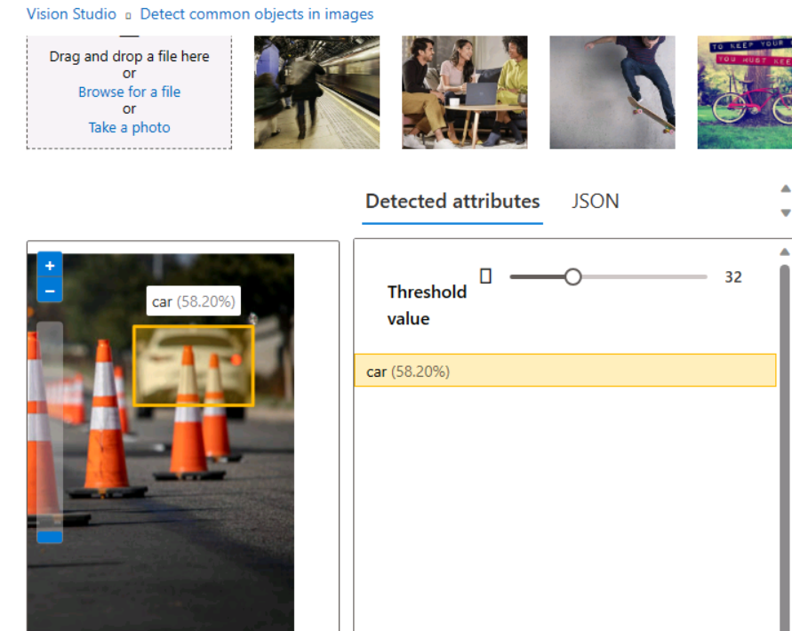
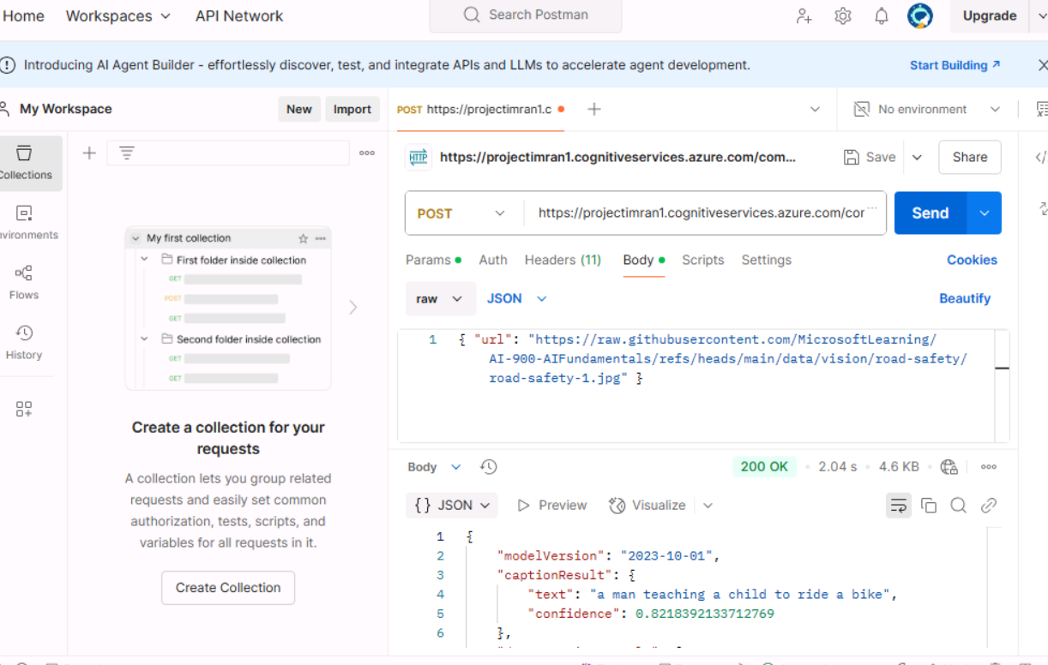
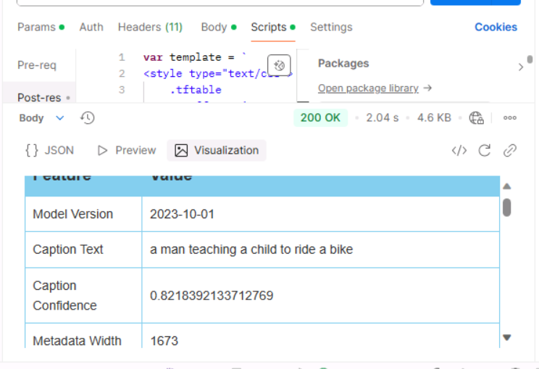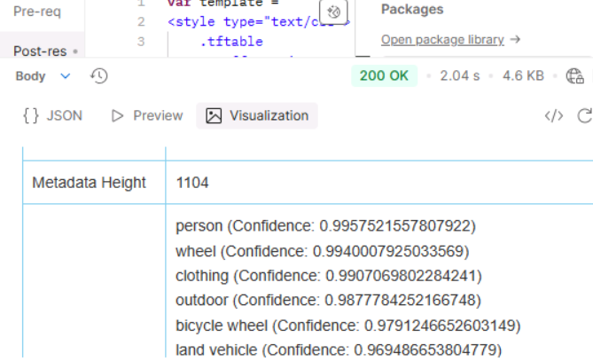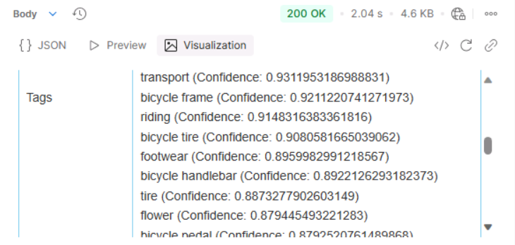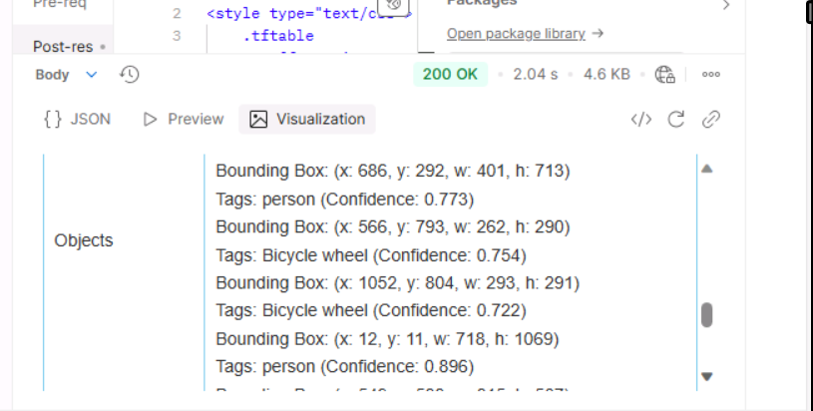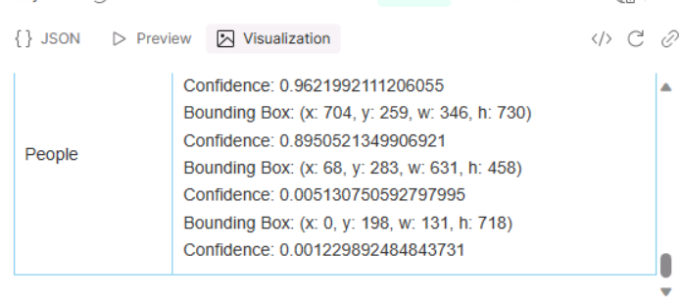

- Milestone 2
Image Classification Using Azure Custom Vision

Objective
To develop a classification model that categorizes vehicle images into seven distinct classes: Auto Rickshaws, Bikes, Cars, Motorcycles, Planes, Ships, and Trains using Azure Custom Vision.
Tasks and Activities

1. Azure Custom Vision Project Setup
- Accessed the Azure portal and created a new Custom Vision project.
- Configured the project for multi-class classification.
- Defined the labels for the vehicle categories.
- Screenshot: Custom Vision project setup in Azure.

2. Image Upload and Tagging
- Uploaded images corresponding to different vehicle types.
- Labeled each image correctly with its respective category.
- Screenshot: Uploaded images and tagging process.

3. Training the Model
- Initiated the model training in Azure Custom Vision.
- The model learned from the dataset to distinguish between different vehicle categories.
- Screenshot: Training process in Azure Custom Vision.

4. Evaluating Model Performance
- Examined key performance metrics: Precision, Recall, and Accuracy.
- Analyzed performance scores to determine classification effectiveness.
- Adjusted training parameters as necessary for optimization.
- Screenshot: Model performance metrics.

5. Testing the Model
- Uploaded new images for testing.
- Verified if the trained model correctly categorized the vehicles.
- Analyzed misclassified images and identified potential improvements.
- Screenshot: Test results of the trained model.
Outcomes
✅ Vehicle images successfully classified into seven categories. ✅ Model performance evaluated based on Precision and Recall. ✅ Screenshots captured for all major steps. ✅ Insights gained for improving classification accuracy.

- Azure Custom Vision Project Setup: Screenshot of the project creation and configuration in the Azure Custom Vision portal.
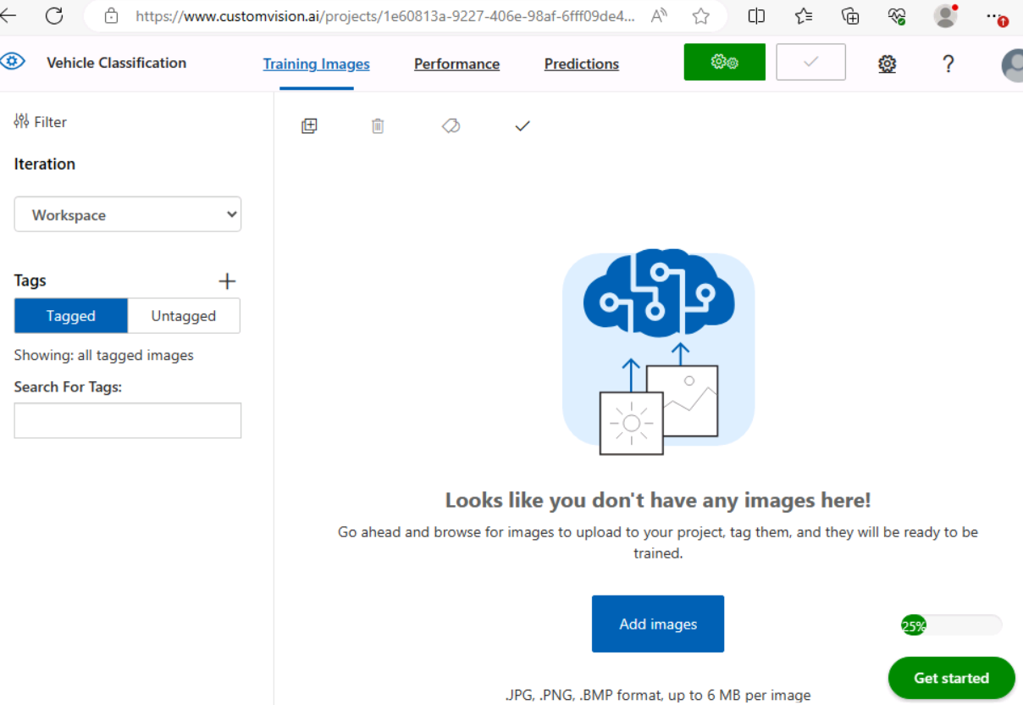
- Image Upload and Tagging: Screenshot showing images uploaded and tagged with different vehicle categories (Auto Rickshaws, Bikes, Cars, Motorcycles, Planes, Ships, Trains).
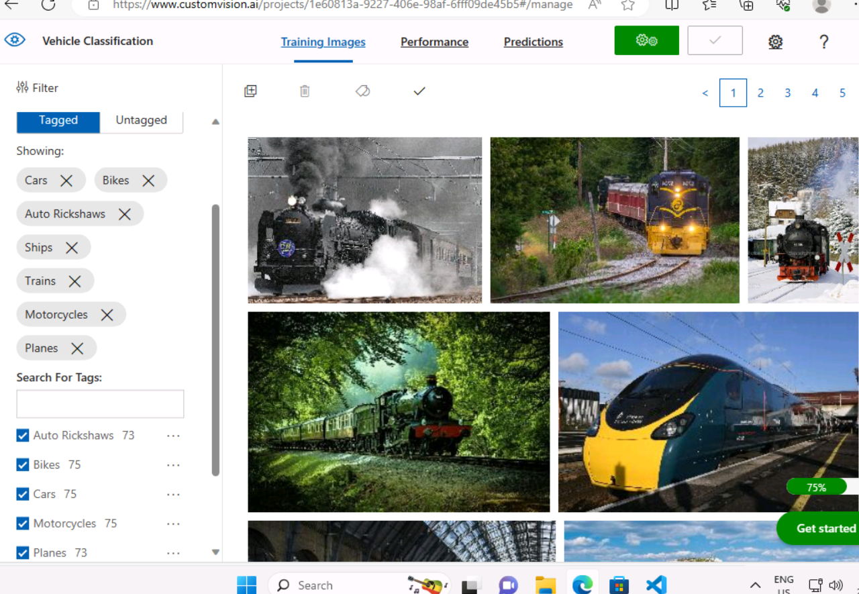
- Training the Model: Screenshot of the model training process in the Custom Vision portal.
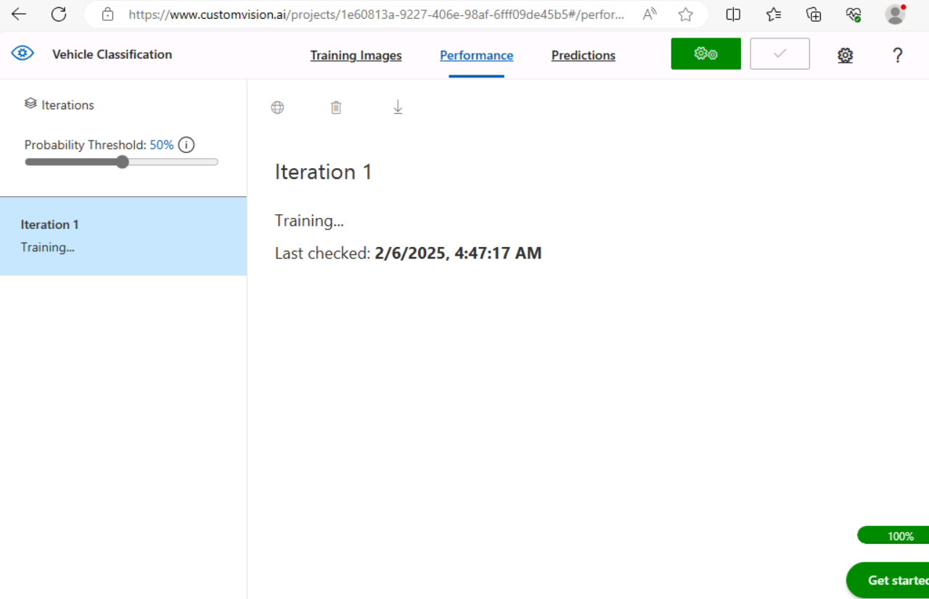

- Model Performance Metrics: Screenshot displaying the evaluation metrics such as Precision, and Recall.
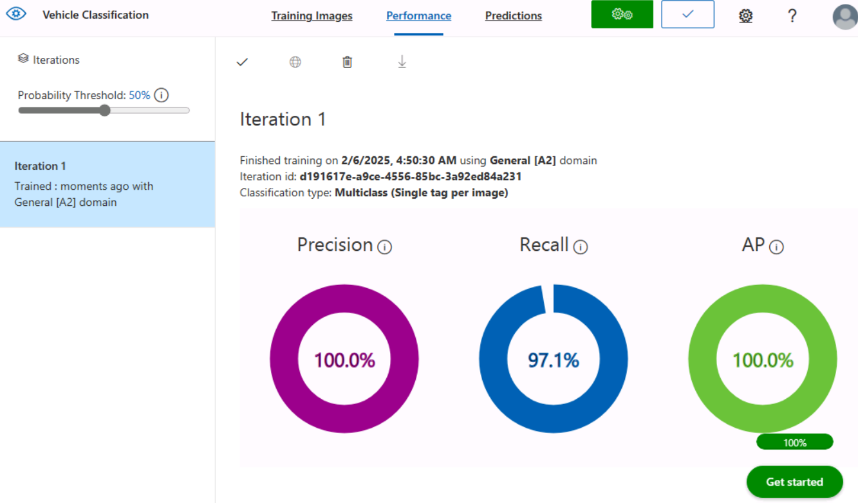
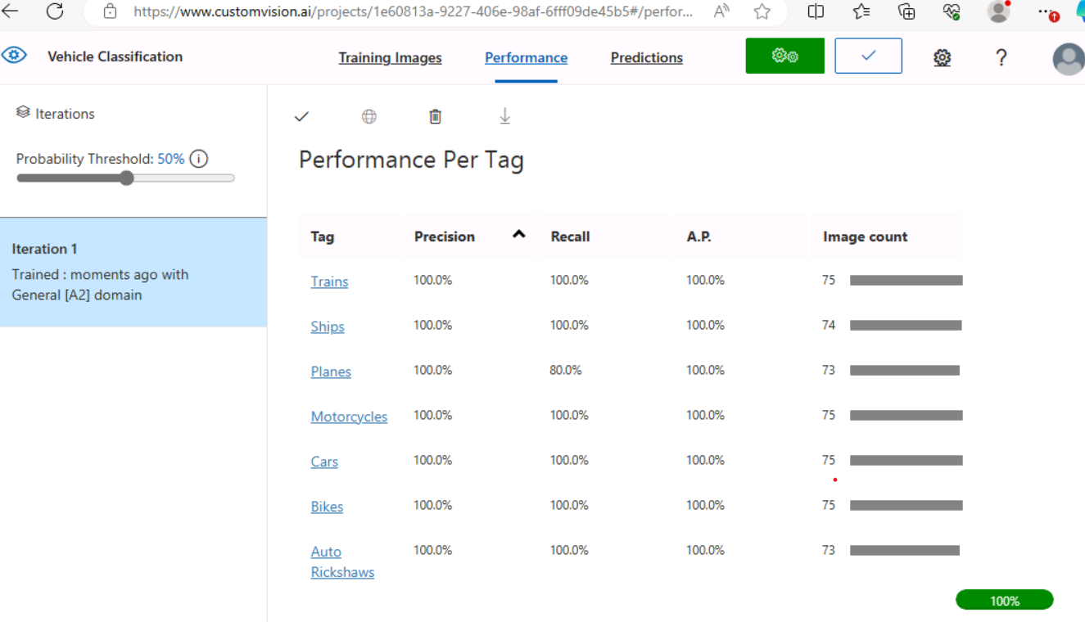

- Testing Results: Testing results of trained model.
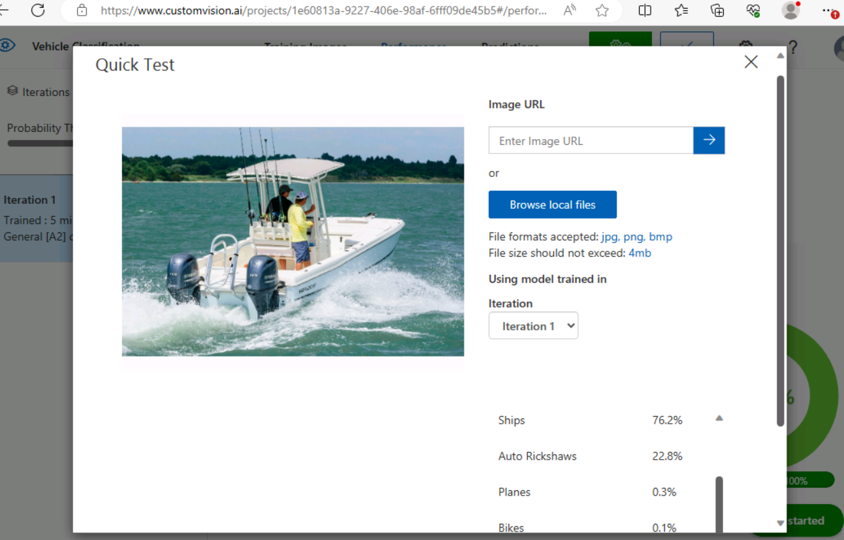

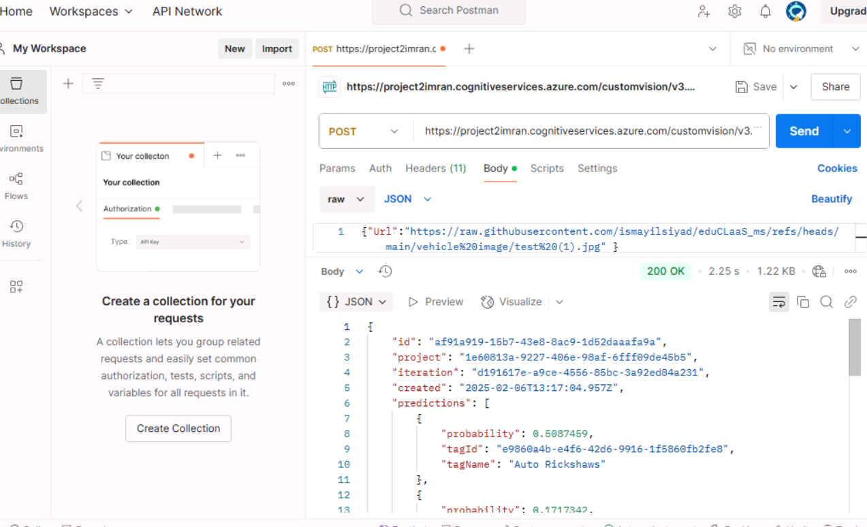
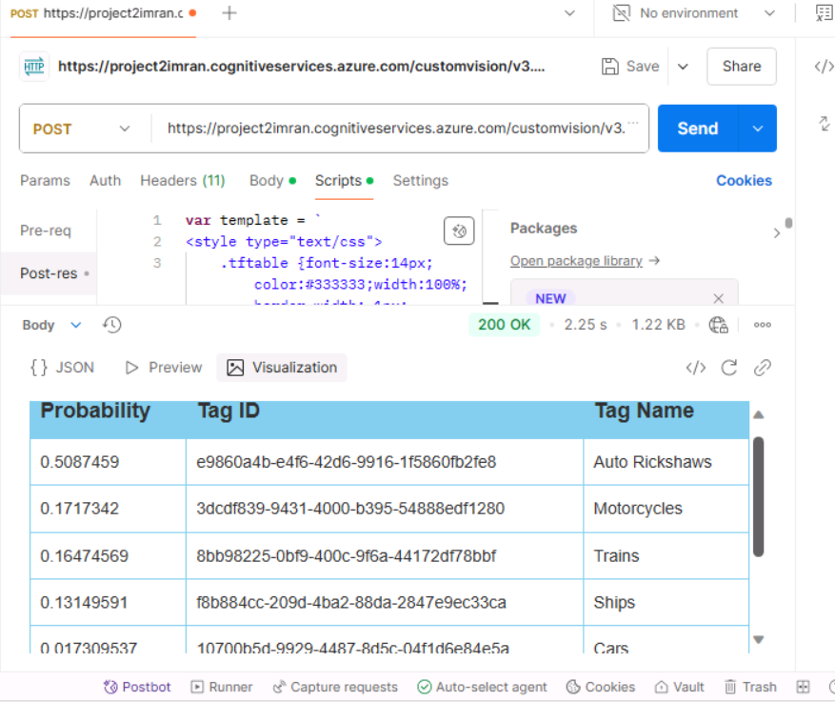
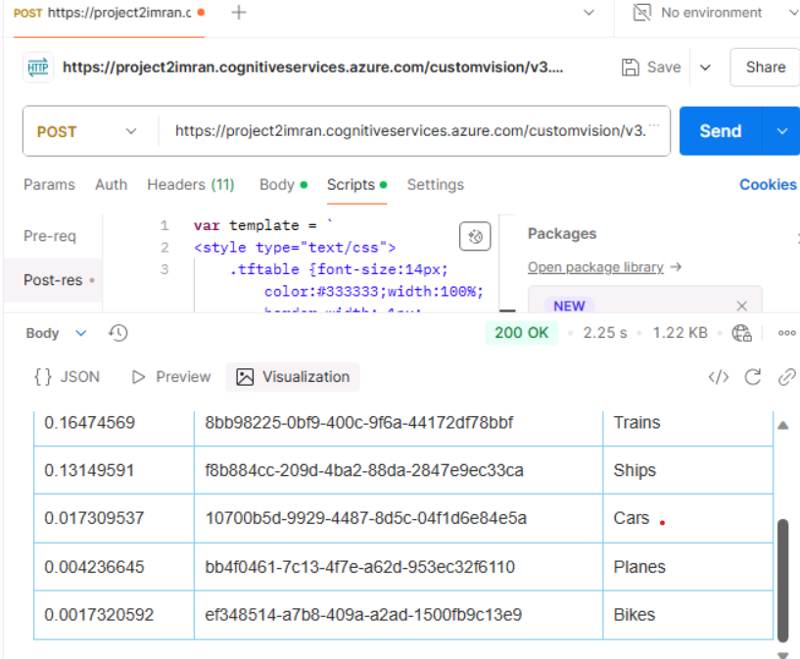
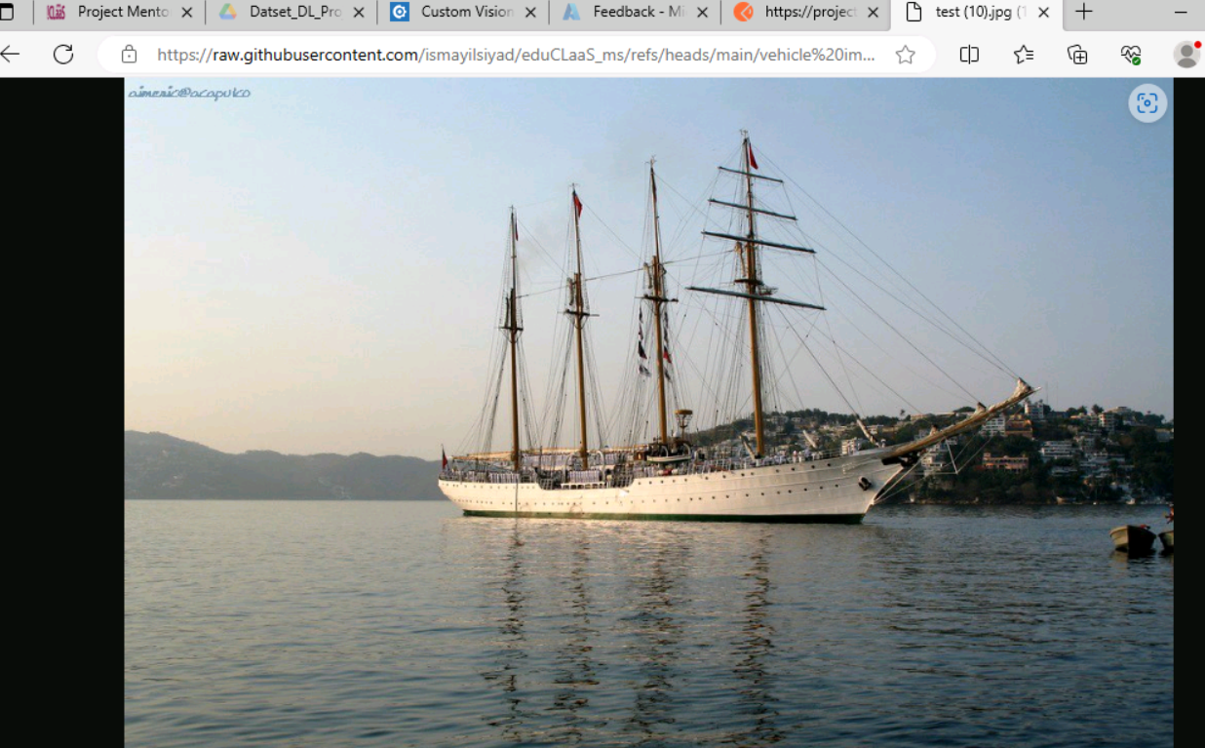

- Milestone 3

Text Analysis on Customer Reviews
This milestone focuses on analyzing customer reviews using Azure Language Studio to extract sentiment, key phrases, and named entities. Below is a breakdown of the tasks and activities involved, along with screenshots (as referenced in the project report).
Tasks and Activities
Azure Language Service Resource Setup
  - Created an Azure Language resource in the Azure portal.
  - Configured the resource for sentiment analysis and named entity recognition.
  - Screenshot: Azure Language service resource setup.
Dataset Upload to Language Studio
  - Uploaded the customer review dataset to Azure Language Studio.
  - Ensured that the dataset contained various customer feedback samples.
  - Screenshot: Dataset uploaded successfully to Language Studio.
Text Analysis Configuration
  - Set up Sentiment Analysis and Opinion Mining to categorize reviews as Positive, Neutral, or Negative.
  - Enabled Named Entity Recognition (NER) to identify key terms like product names, company names, and locations.
  - Screenshot: Sentiment analysis setup in Language Studio.
Sentiment Analysis Results
  - Processed the dataset using Azure's AI model.
  - Generated insights on overall sentiment distribution.
  - Screenshot: Analysis output showing classified sentiments (Positive, Neutral, Negative).
Key Phrases and Named Entity Recognition
  - Extracted key phrases from customer reviews.
  - Identified named entities (such as brands, locations, and products).
  - Screenshot: Key phrases and entity extraction results.
Outcomes
✅ Customer reviews successfully categorized as Positive, Neutral, or Negative.
✅ Named entities and key phrases extracted to provide insights into common themes.
✅ Sentiment trends identified for better understanding of customer feedback.
✅ Screenshots documented for all major steps.

- Azure Language Service Resource Setup: Screenshot of the Azure Language service resource created in the Azure portal.
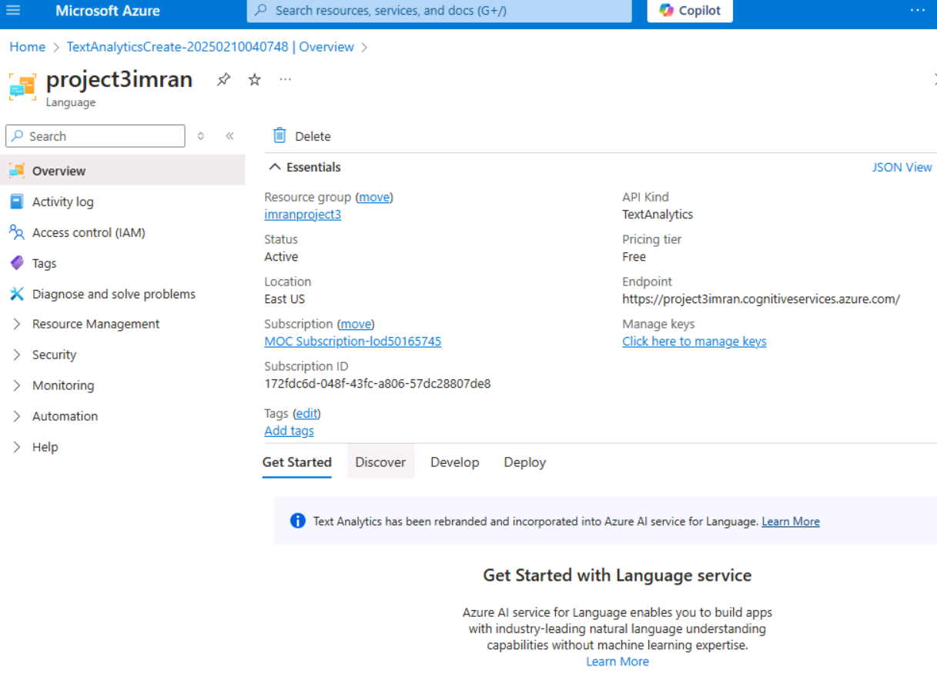

- Dataset Upload to Language Studio: Screenshot showing the customer review dataset uploaded to Language Studio.
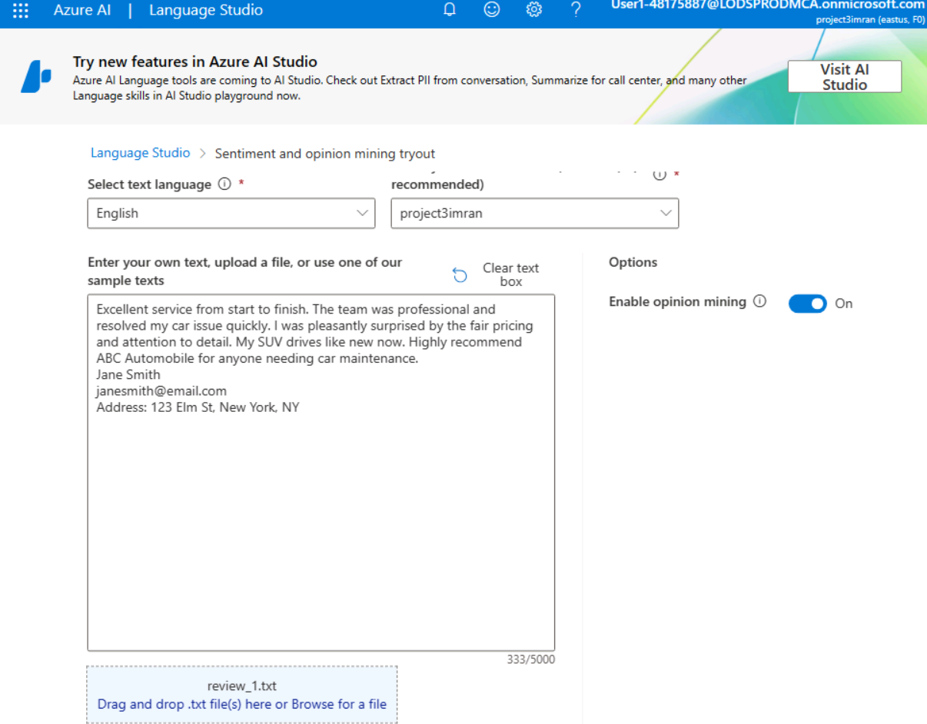

- Text Analysis Configuration: Screenshot of the sentiment analysis setup and configuration in Language Studio.
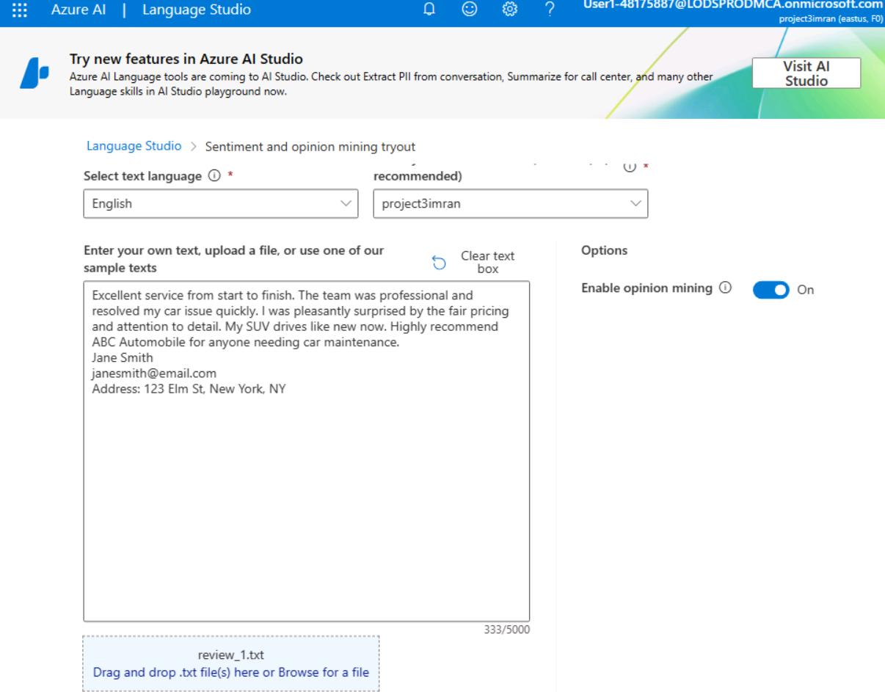
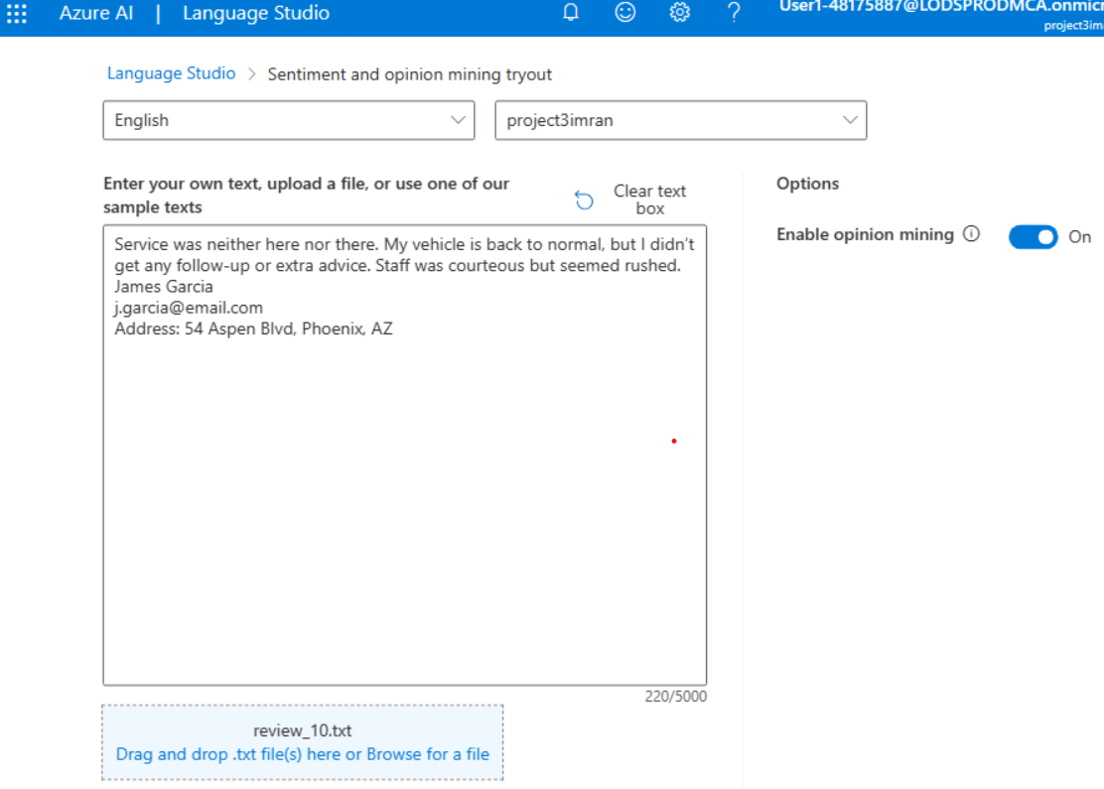
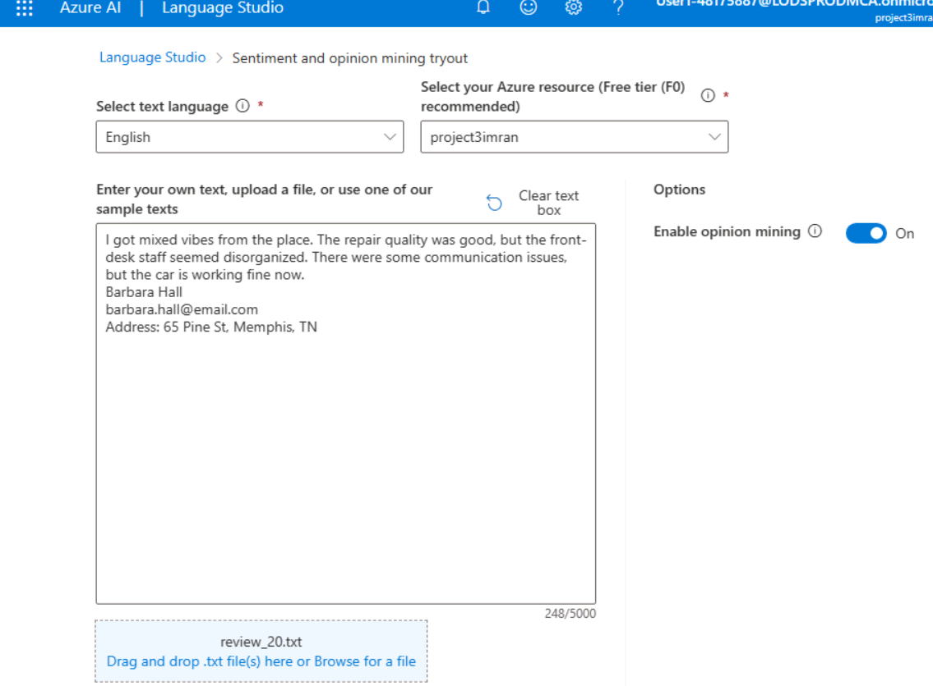

- Sentiment Analysis Results: Screenshot showing sentiment analysis results for the reviews (Positive, Neutral, Negative).
1
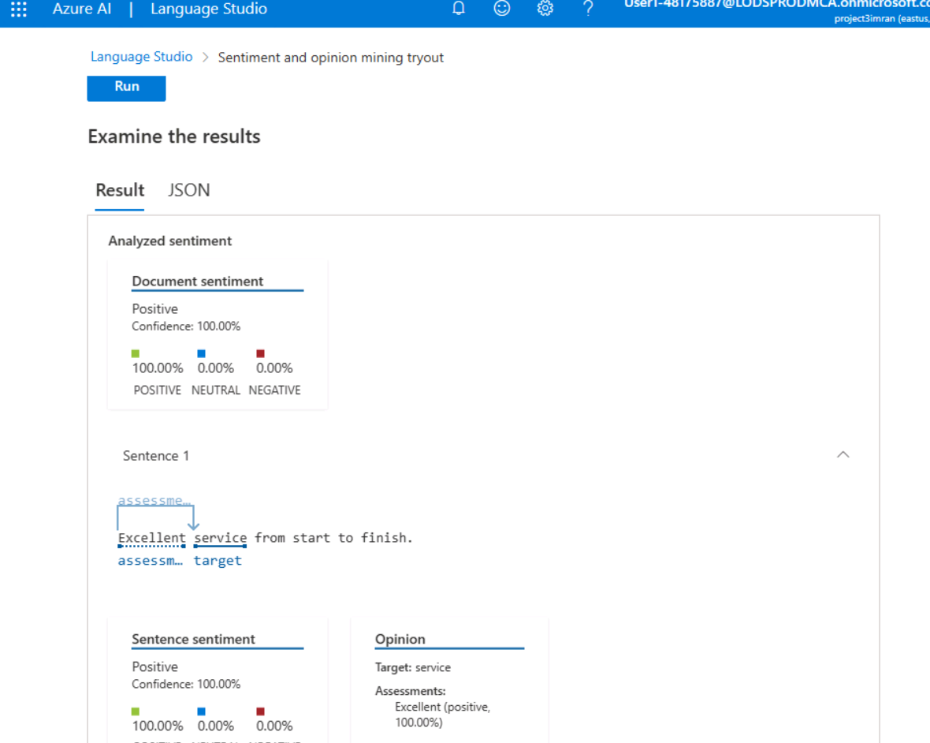
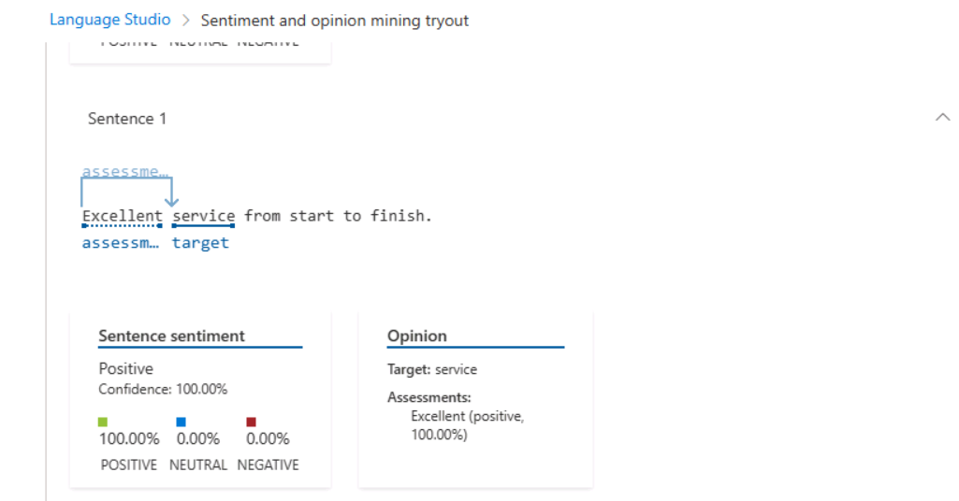
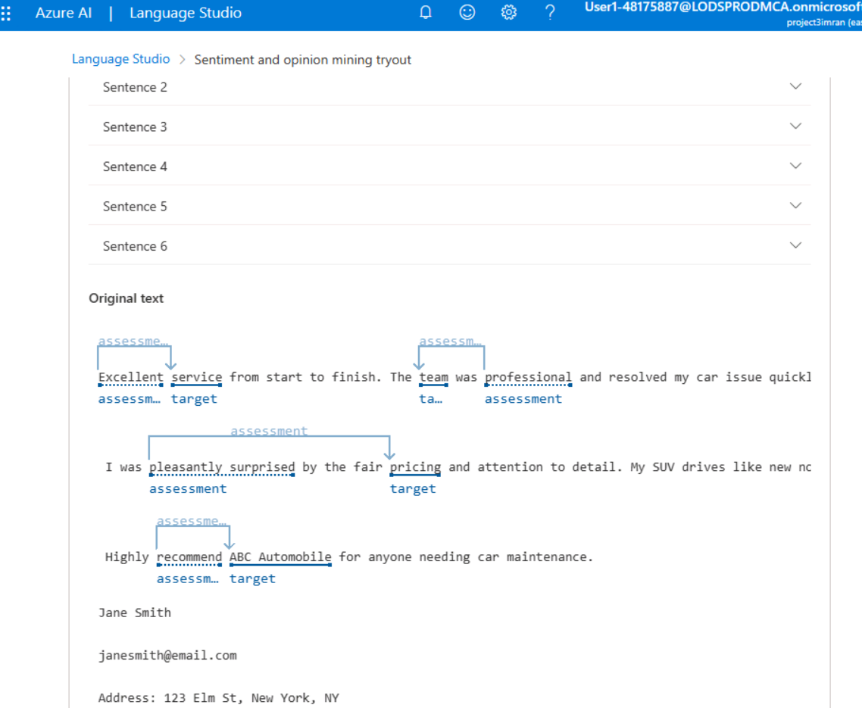

2
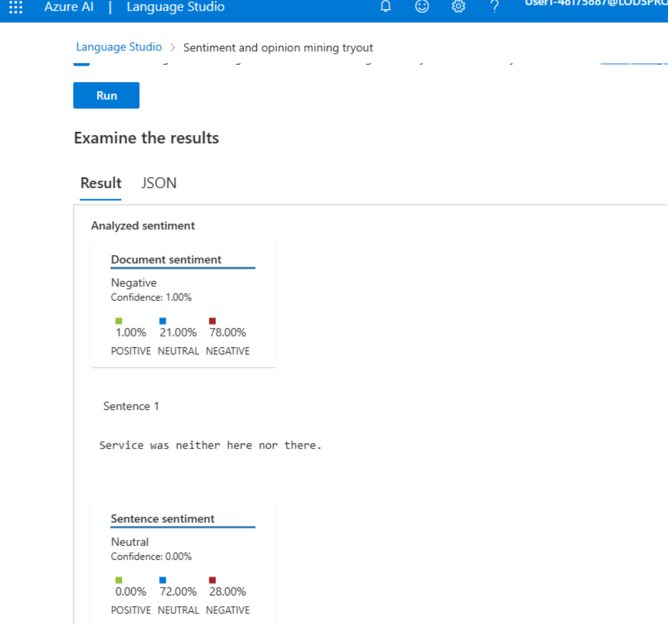
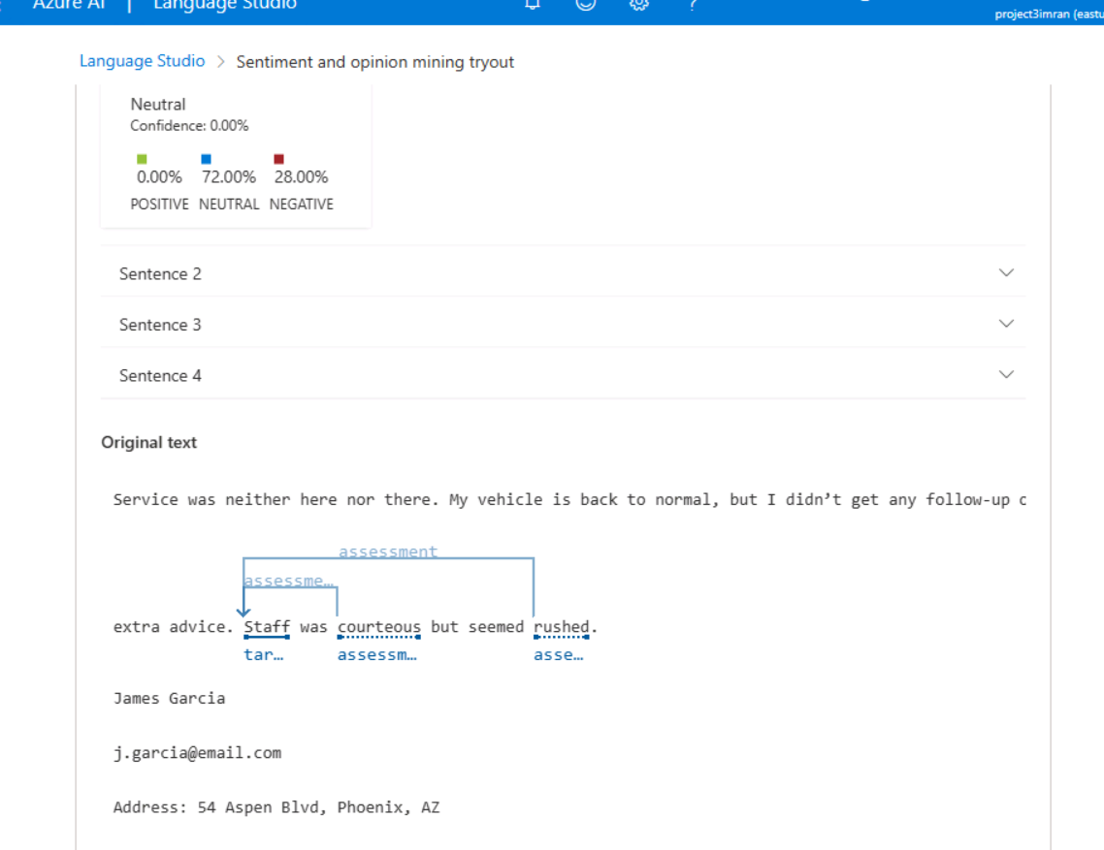

3
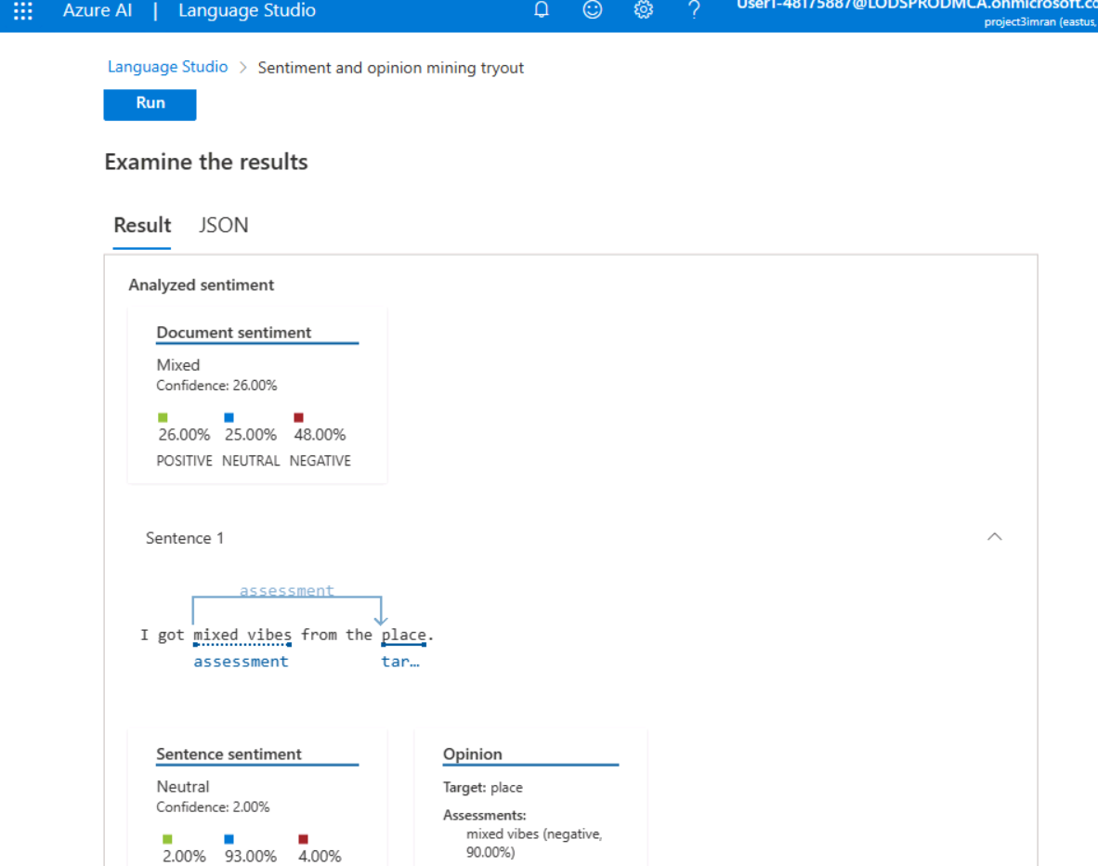
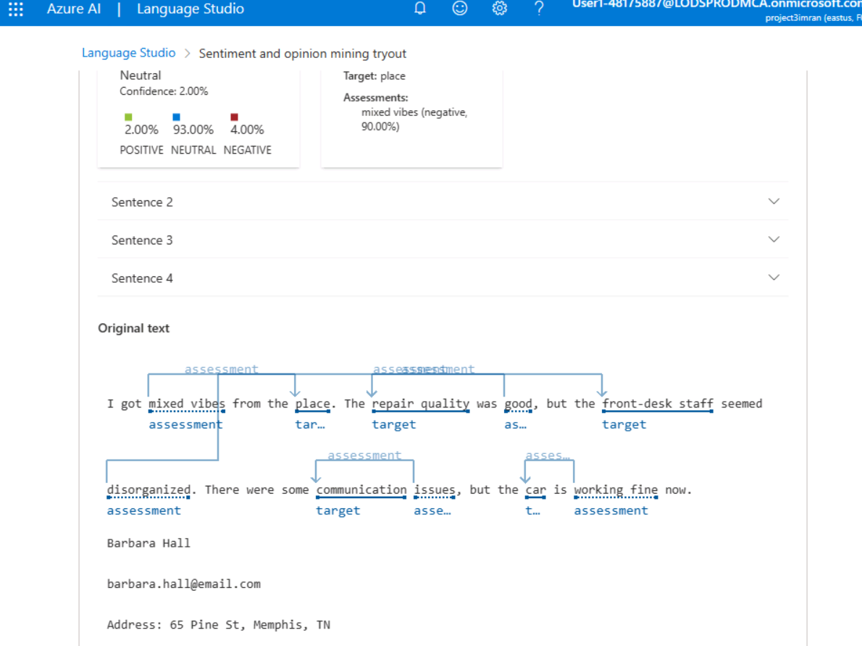

- Key Phrases and Named Entity Recognition: Screenshot of the extracted key phrases and named entities from the customer reviews.
1
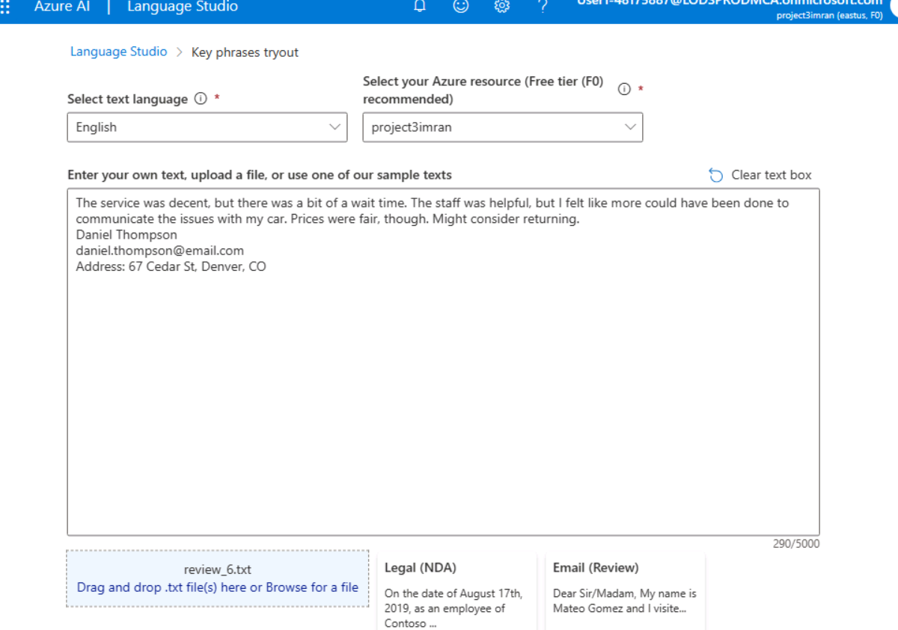
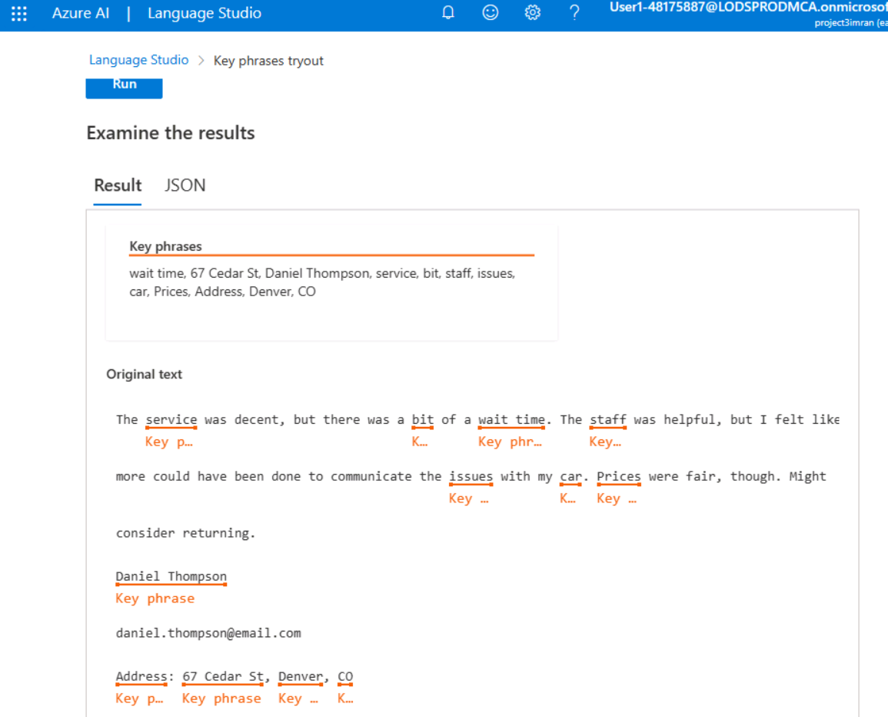

2
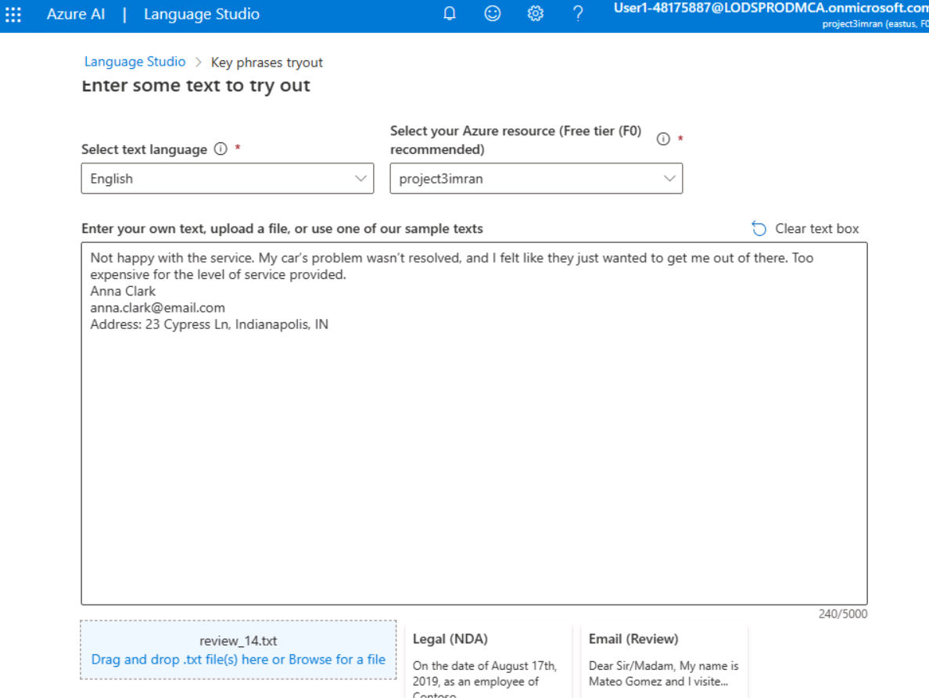
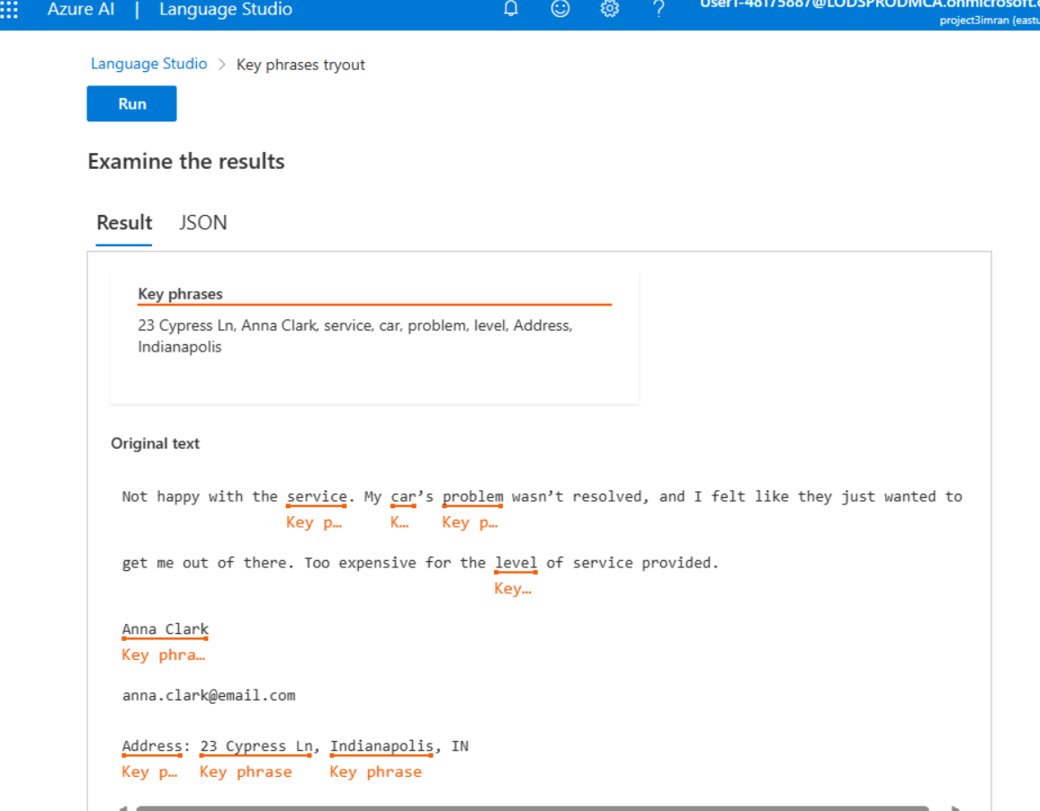
3
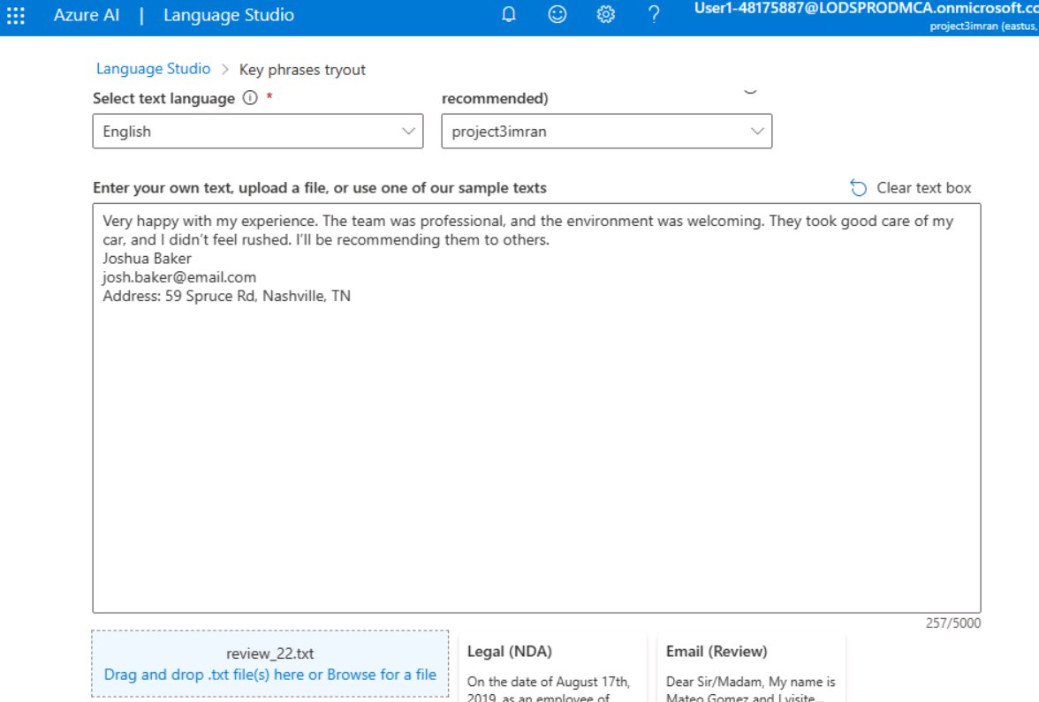
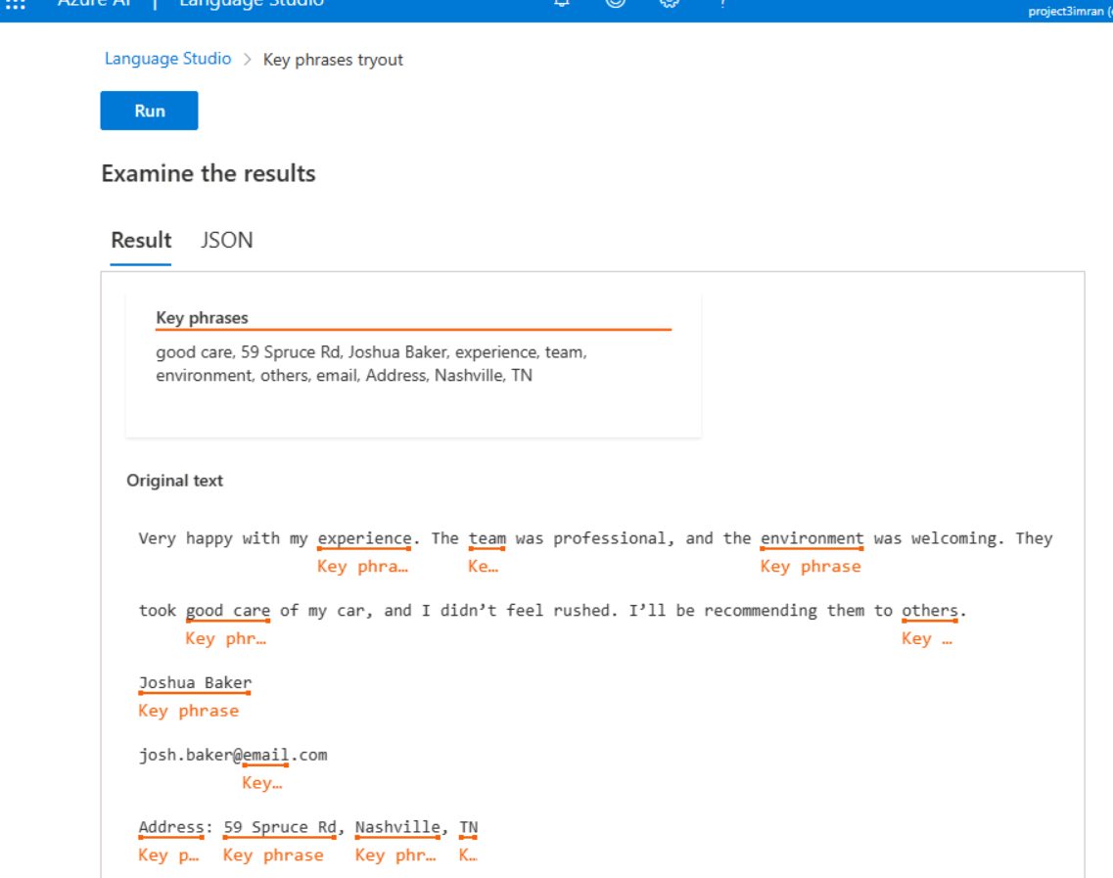

1
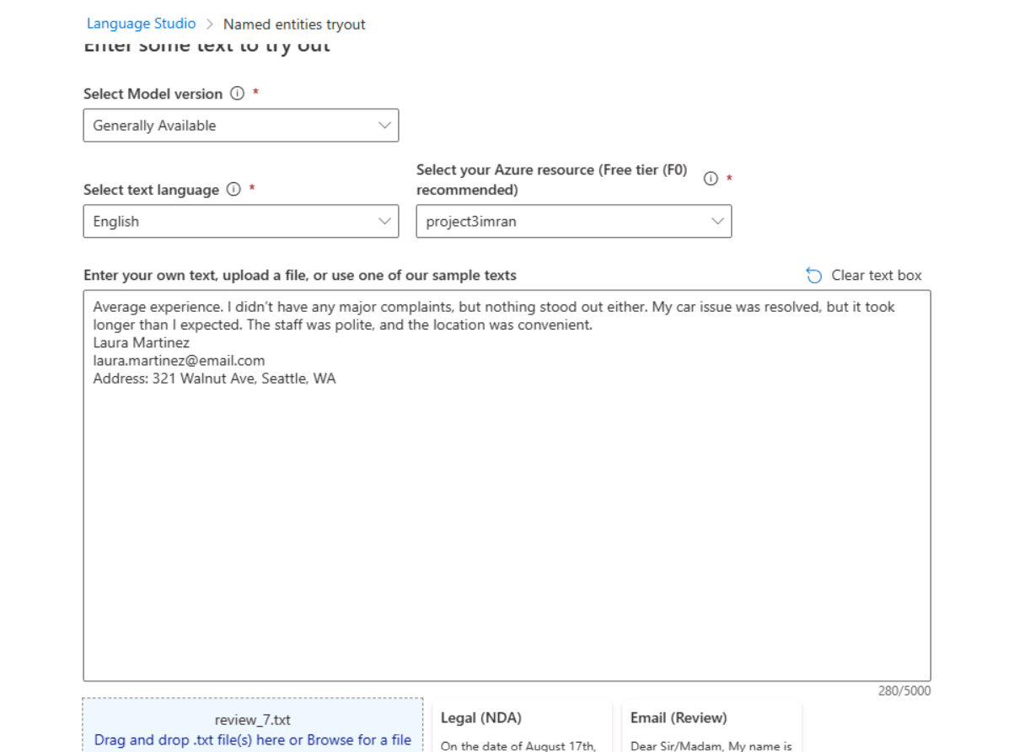
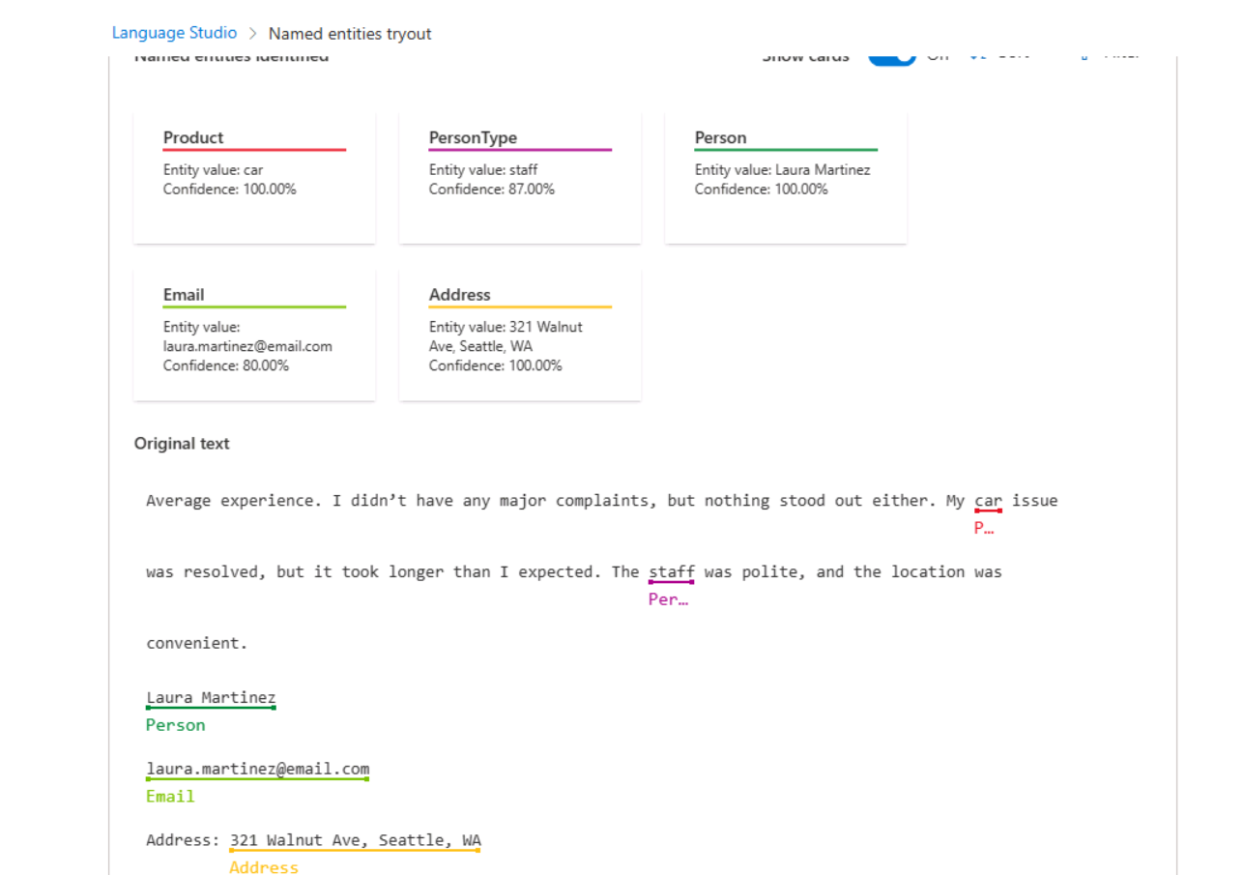
2
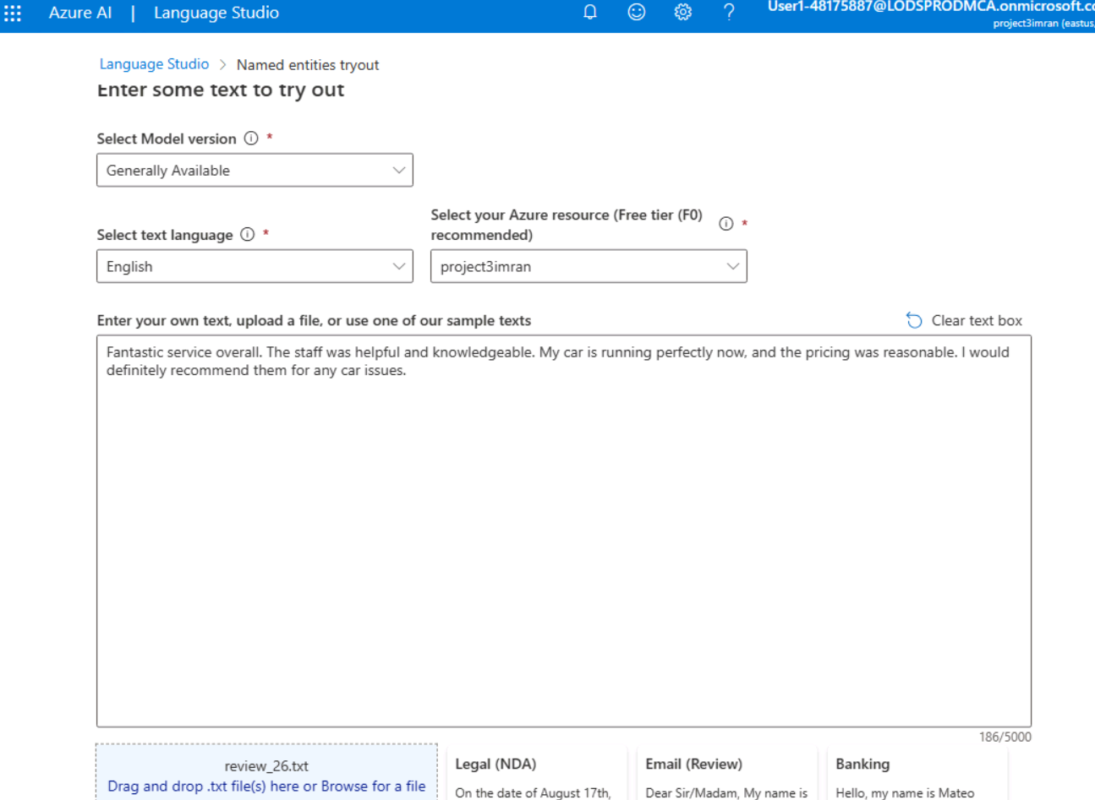
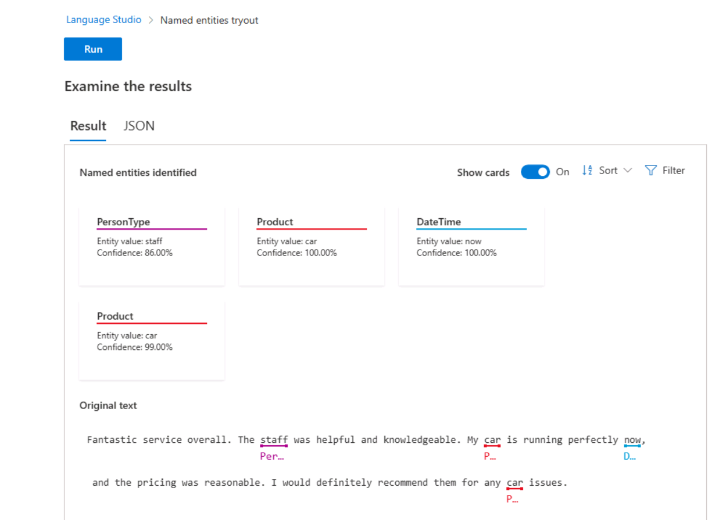
3
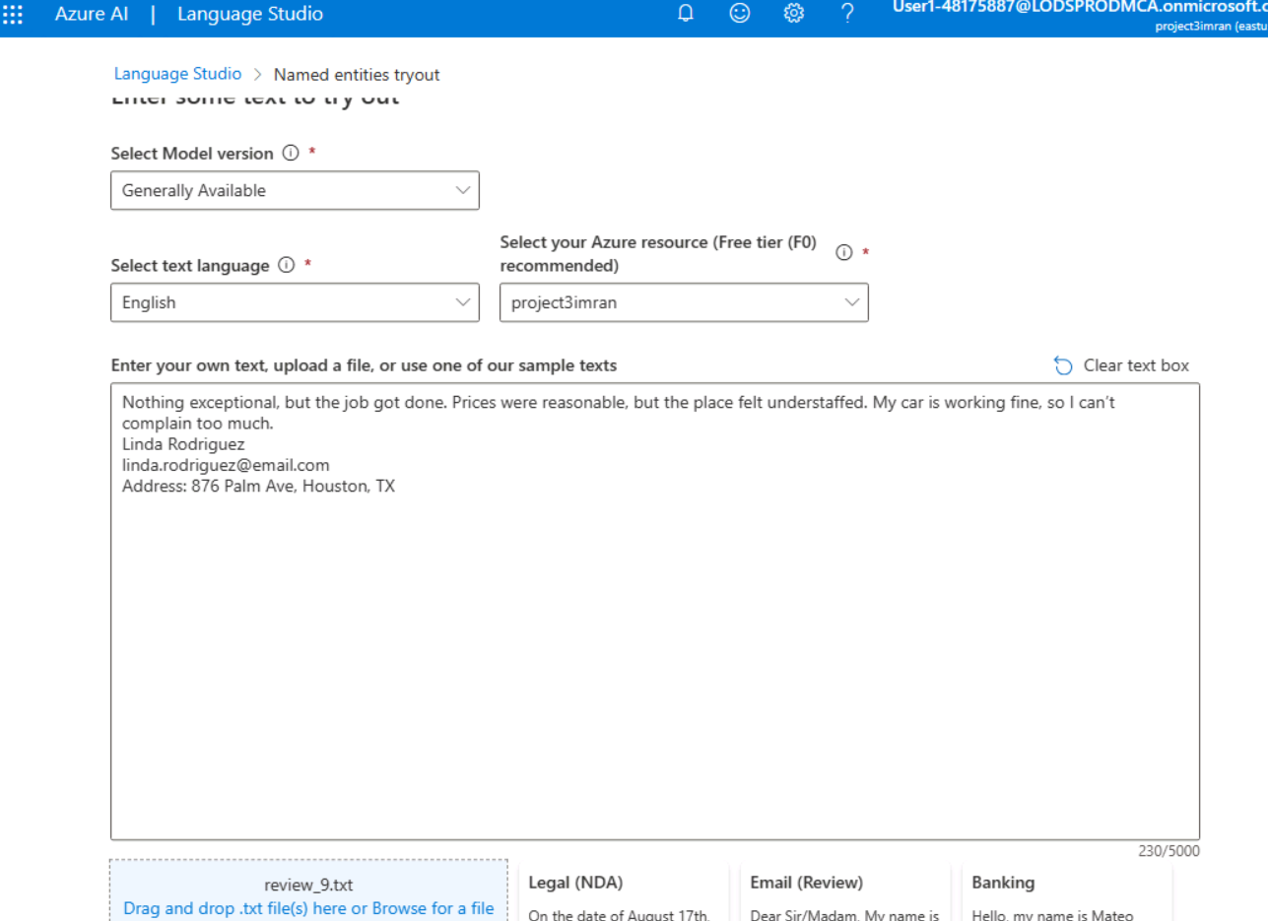
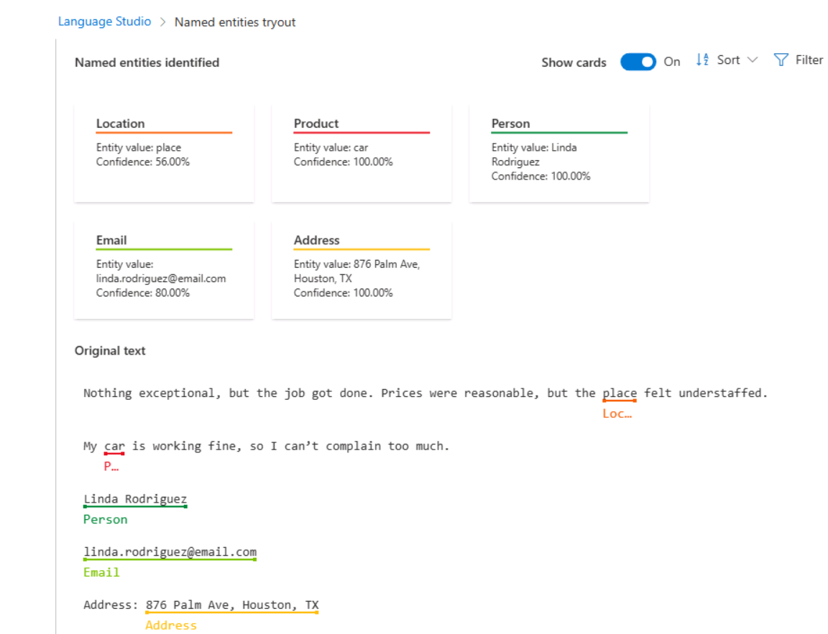

1
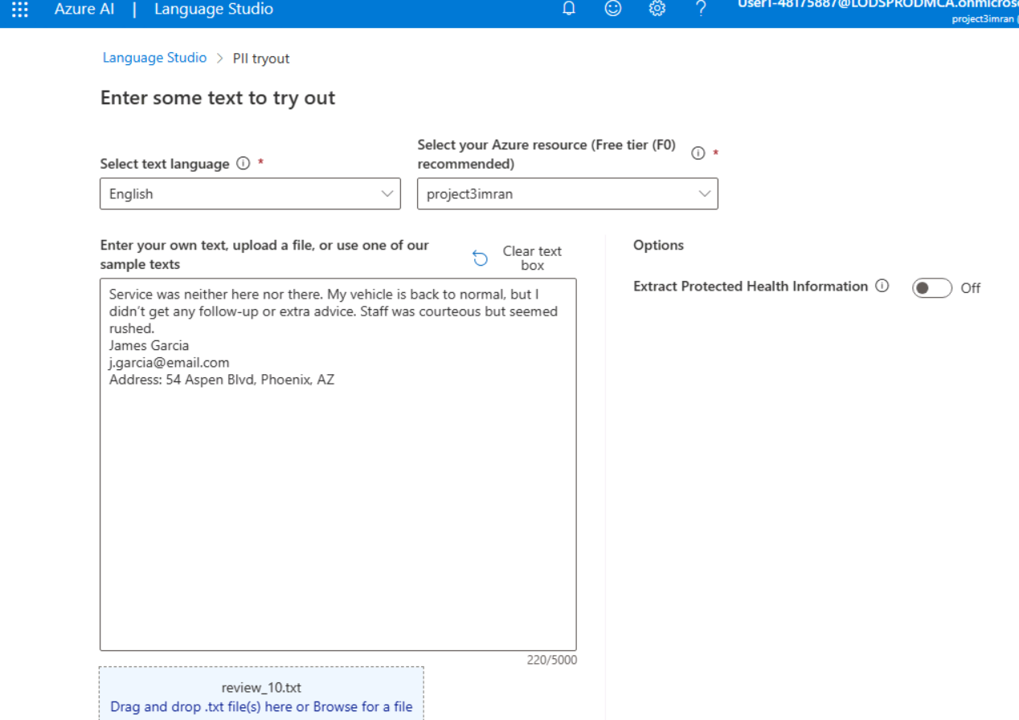
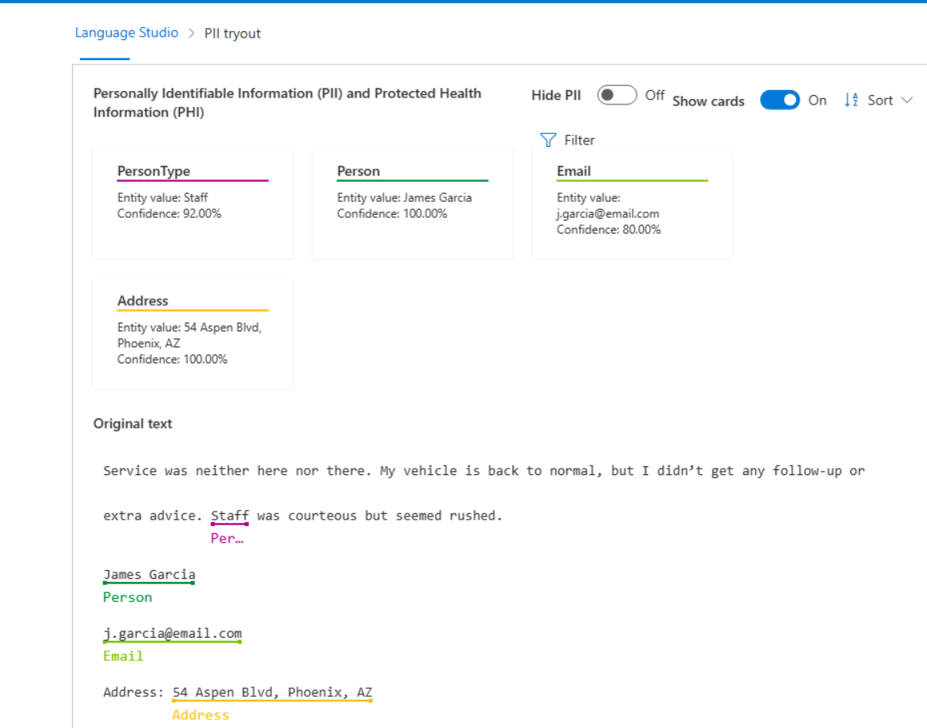

2
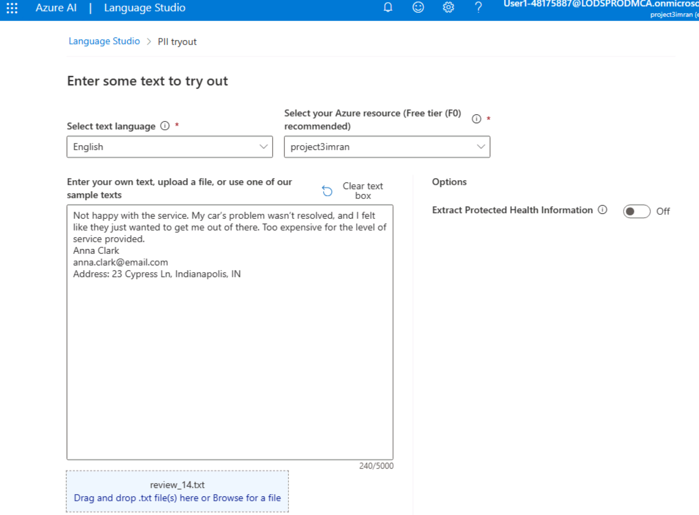
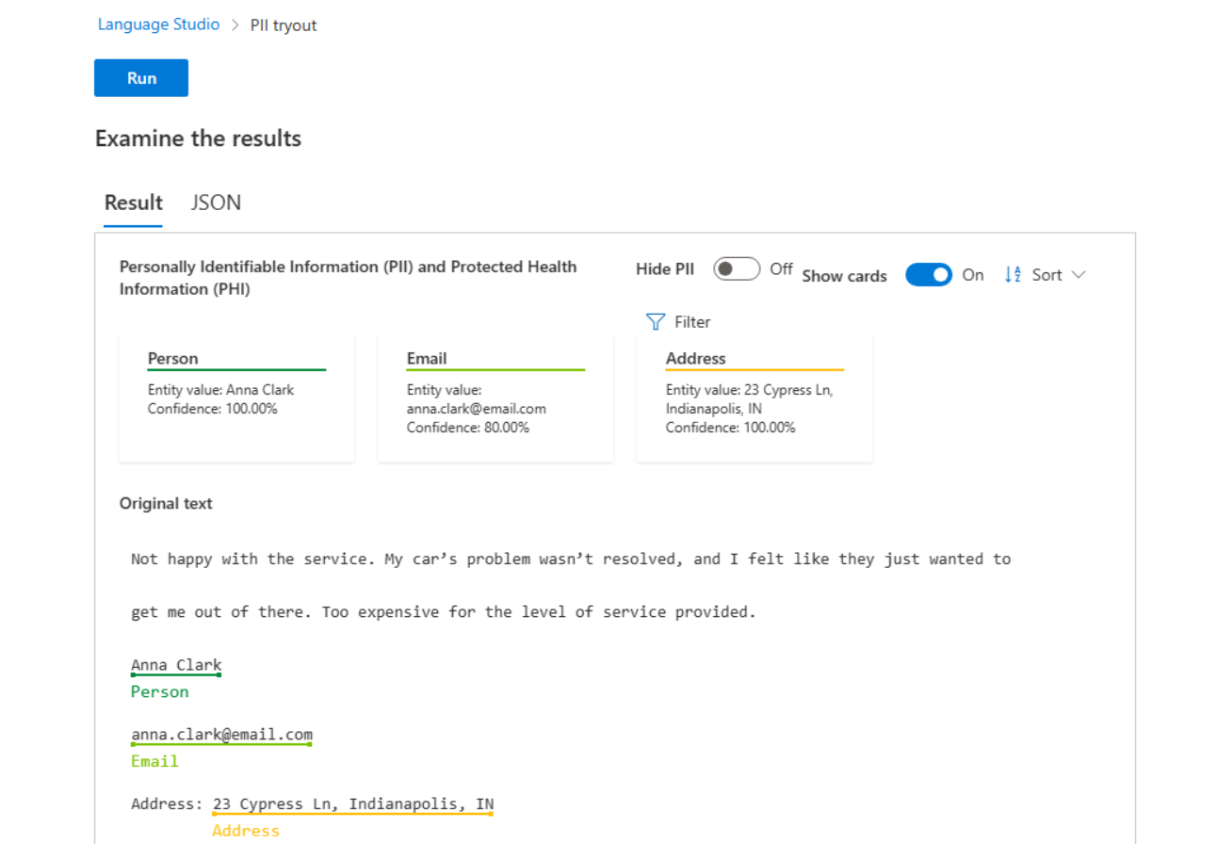
3
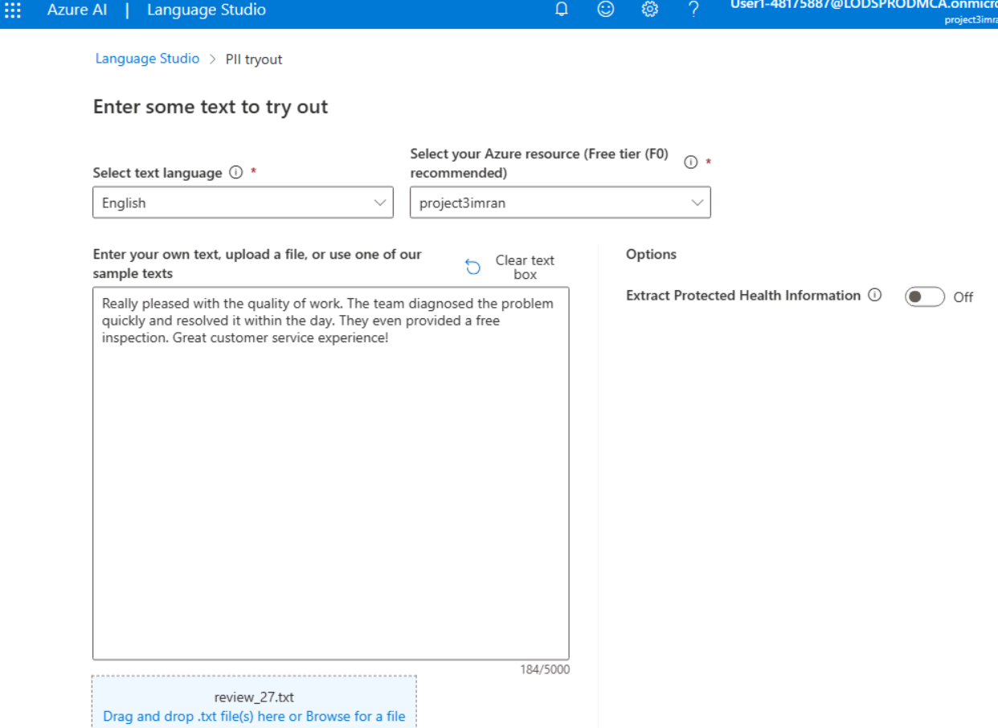
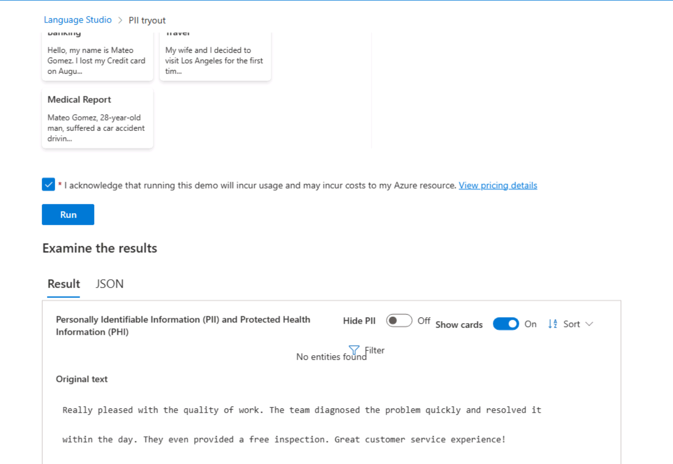
1
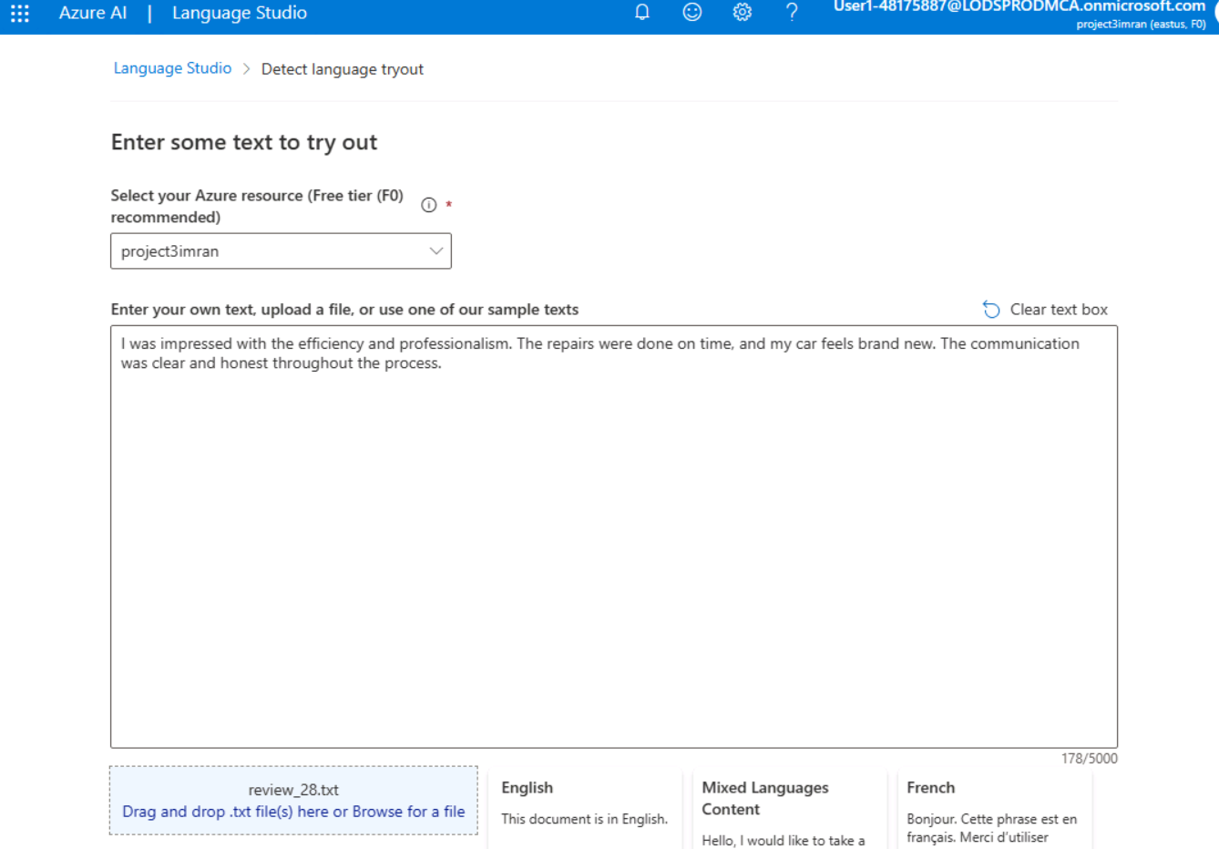
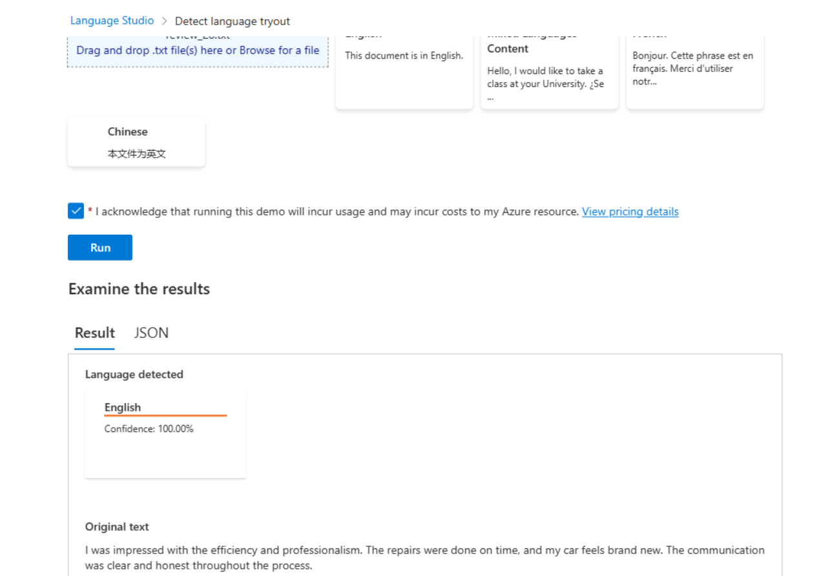
- Milestone 4
Video Analysis Using Azure Video Indexer

Objective:
The goal of this milestone is to analyze two industry-related videos using **Azure Video Indexer** and extract insights such as keywords, topics, and named entities. These insights will then be embedded into HTML pages for internal presentations and decision-making.

Tasks and Activities:

1. Azure Video Indexer Portal Setup:
- Created an Azure Video Indexer account and configured the necessary resources in the Azure portal.
- **Screenshot:** Azure Video Indexer account setup and resource configuration.

2. Video Upload to Video Indexer:
- Uploaded the two videos: "Can AI Fix Traffic?" and "How EVs Are Shaking The Car Parts Supplier Industry" to the Video Indexer.
- **Screenshot:** Videos successfully uploaded to the Video Indexer portal.

3. Insights Extraction:
- Used Azure Video Indexer to analyze the videos and extract insights such as keywords, topics, and named entities.
- **Screenshot:** Insights extracted from the videos, including keywords and named entities.

4. Embedding Insights into HTML Pages:
- Generated HTML pages with embedded video players and insights widgets for both videos.
- **Screenshot:** HTML pages with embedded video players and insights widgets.

Outcomes:
✅ Videos successfully analyzed, and insights extracted.
✅HTML pages created with embedded video players and insights widgets.
✅Screenshots documented for all major steps.

1.Azure Video Indexer Portal Setup: Screenshot of the Video Indexer account and resource configuration in the Azure portal.
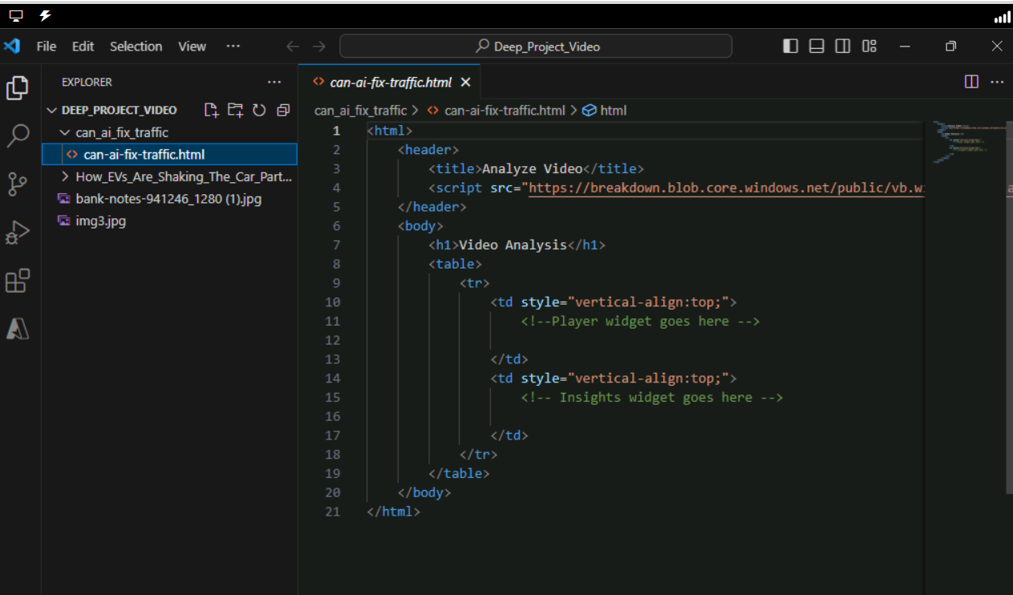

2.Video Upload to Video Indexer: Screenshot showing the videos “Can AI Fix Traffic?” and “How EVs Are Shaking The Car Parts Supplier Industry” uploaded to the Video Indexer.
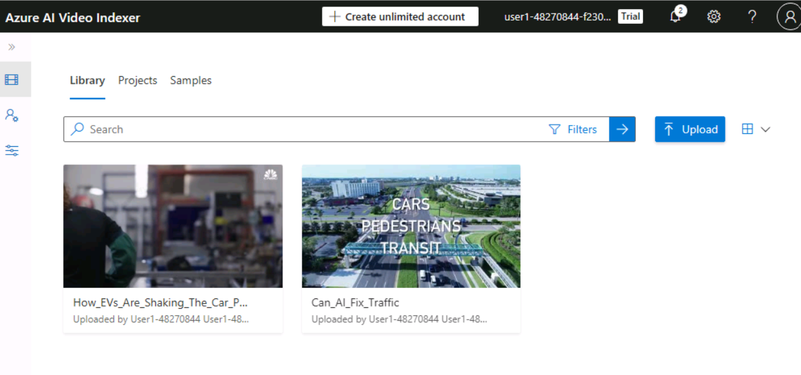

3.Insights Extraction Results: Screenshot showing the video insights such as keywords, topics, and named entities in the Video Indexer portal.
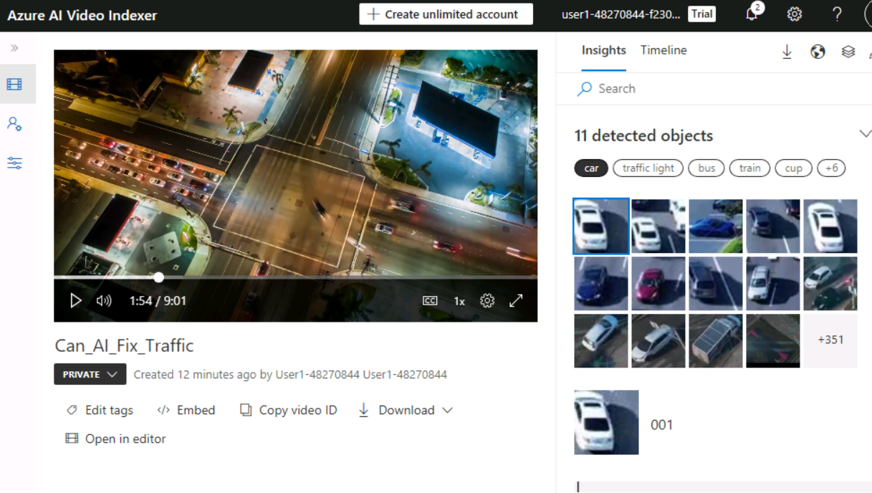
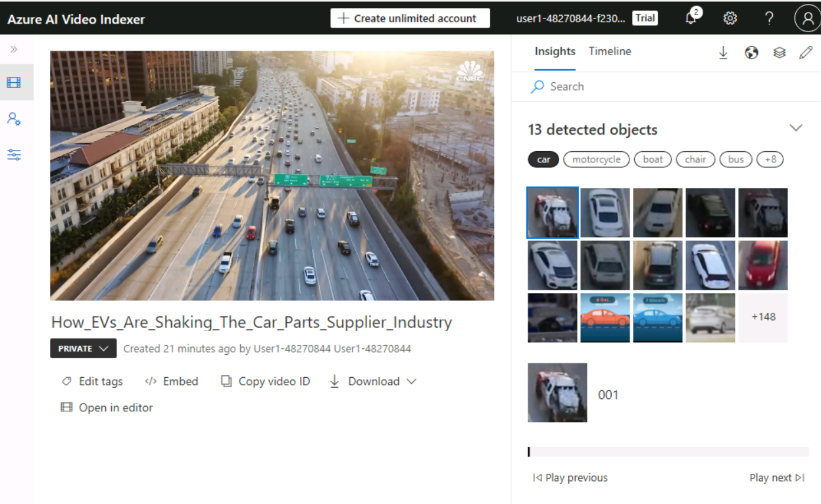

4.HTML Templates with Embedded Widgets: Screenshot showing the HTML pages (can-ai-fix-traffic.html and ev-car-parts-supplier.html) with embedded video player and insights widgets.
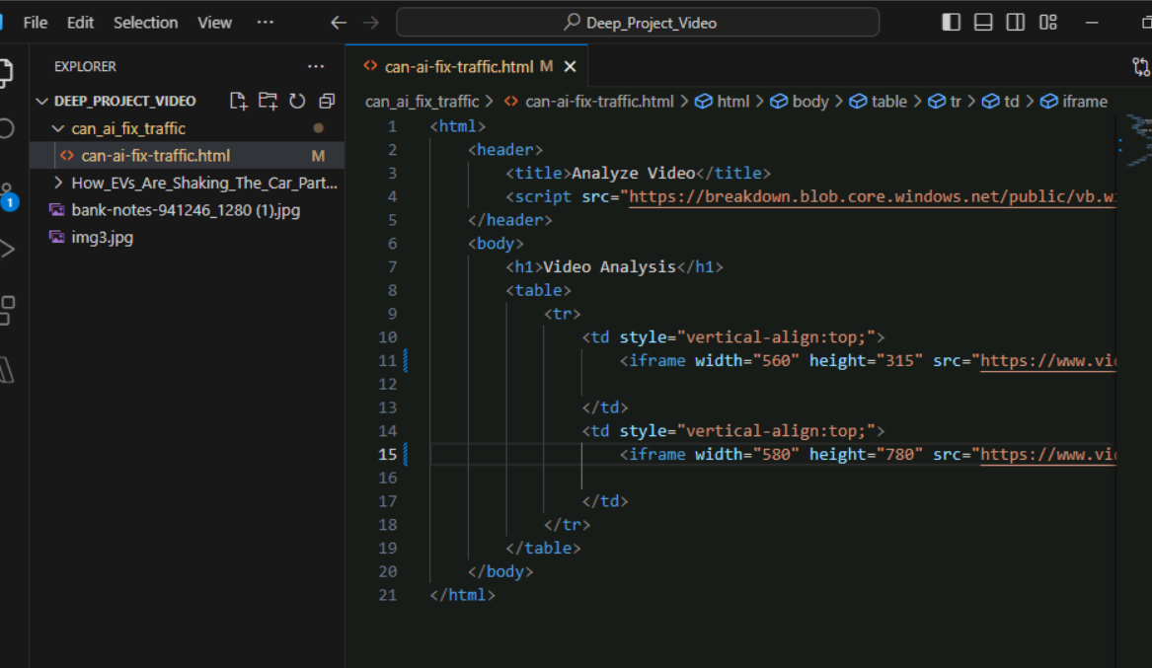
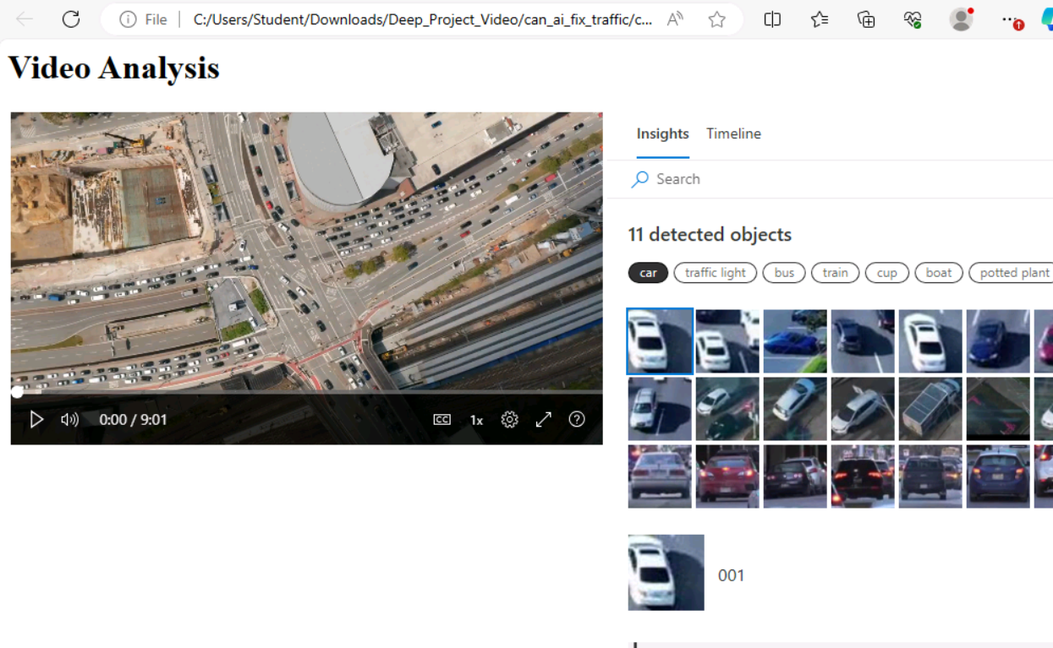
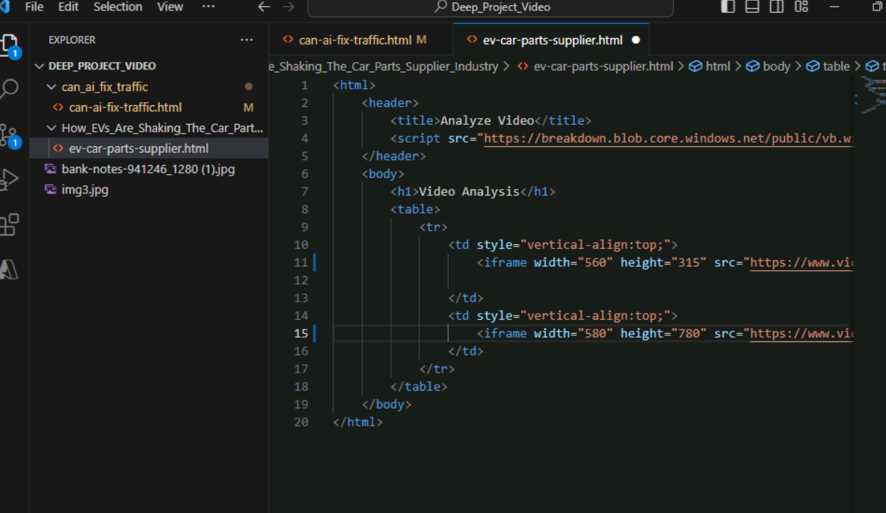
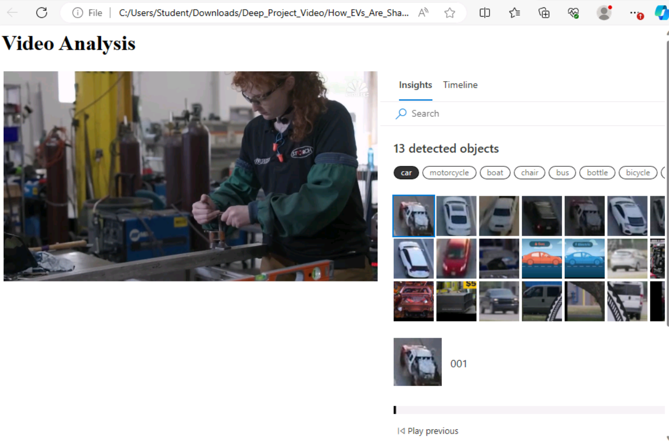

- Conclusions and Future Scopes
Conclusions:
- The project successfully demonstrated the use of Azure AI services (Azure AI Vision, Custom Vision, Language Services, and Video Indexer) to address real-world business scenarios in the automotive industry.
- Each milestone provided valuable insights, such as traffic pattern analysis, vehicle classification, customer sentiment analysis, and video content insights, which can help ABC Automobile Support Co. improve its operations and customer satisfaction.
- The integration of Azure AI services proved effective in automating tasks and extracting meaningful data for decision-making.

Future Scopes:
1. Model Optimization: Further fine-tuning of the image classification model to improve accuracy and reduce misclassifications.
2. Real-time Analysis: Implementing real-time video and image analysis for live traffic monitoring and customer feedback processing.
3. Scalability: Expanding the use of Azure AI services to other areas of the business, such as predictive maintenance and supply chain optimization.
4. Enhanced Sentiment Analysis: Incorporating more advanced sentiment analysis techniques to capture nuanced customer emotions and feedback.
5. Integration with Other Tools: Integrating the AI solutions with other business intelligence tools for a more comprehensive data analysis platform.

By continuing to leverage Azure AI services, ABC Automobile Support Co. can further enhance its data-driven decision-making processes and maintain a competitive edge in the automotive industry.

